# Academic year 2023/2024 Autumn Term

**CS7079 Data Warehousing and Big Data**

**Group-2**

**CASE STUDY SCENARIO: Blue Sky Online Consumer Electronics Retailer**

Blue Sky Online is an online consumer electronics retailer founded in 1990. It conducts online business across UK and Europe via different channels such as Amazon, eBay, Tesco and its own website. Currently, the company offers more than ten thousand products organised in about ten categories and in more than 500 brands.

The dynamic and highly competitive nature of the consumer electronics retail industry means that businesses in this industry are experiencing different decision-making challenges in relation to pricing, targeting high value consumers, consumer satisfaction and product offerings. Retailers are always under huge pressure to invest in new information and communication technologies to gain competitive advantages and optimise business processes.

Blue Sky has a huge customer base across the UK and Europe. Marketing and Customer Relationship managers couldn’t utilise the customer base since it is not maintained properly, and some important information are missing. The details of customers and transactions are managed by different applications such as spreadsheet and google docs.

The company is keen to manage and analyse customer interactions to improve its business relationships with customers, facilitate customer retention and drive sale growth. As a data warehouse developer, you are tasked to design dimensional data models and build a data warehouse based on the following reporting and data analysis requirements of the company compiled by a business analyst.

The implemented data warehouse should consolidate customer information and sale transactions into a central corporate repository so that managers can produce reports and perform analysis that would enable them to provide useful information for their decision-making activities.

**Data and analysis requirements:**

1. Maintain customer database.
2. Analyse purchase or transaction history based on demographic data such as age group, income group, marital status and postcode/City/Country.
3. Identify customer preferences in terms selling channels/ payment payments/.
4. Identify the best and most profitable customers at different periods (month, quarter and year).

**Introduction:**

Current business environments have large and varied data sets generated on a daily basis. These data sets are pivotal in aiding the management personnel to make business decisions that assist their business. Data warehousing is the phenomenon which solves this problem of business managers by creating models that meet the **reporting and analysis requirements of a business.**

The first step is to understand the business problem which prompts the creation of a data warehouse for the given business scenario which can aid the decision-making activities. In this case, the customer database needs to be maintained properly as it is spread along various files and also has some pivotal data missing from those files. Initially, the data given is thoroughly viewed and checked for cleanliness. Then the grain level at which the measures will be created will be identified. Then, the dimensions which need to be created are identified along with their respective primary keys. The next step is the most crucial step which involves creation of fact tables based on the created dimensions and the requirement analysis of the given business scenario. Appropriate measures need to be identified which can solve the business problems with ease. These measures should be able to assist the manager level employees to take tough business decisions based on their results. The overall architecture should be as detailed as possible and tailor-made according to the requirement analysis. The dimensional data model thus created will be tested whether it effectively contributes to business decision making at a later stage.

The customer database will be very well maintained using the dimensional data model created. All the necessary customer information can be easily retrieved using the created model. Analyzing the transactional or purchase history of the customer according to demographic data such as age-group, income-group, marital status, city or postcode needs a fact table which can include measures such as total revenue for each customer. Similarly, identifying the customer preferences and most profitable customers also need fact tables with measures such as count of preferred selling channel for each customer and profit respectively. The created fact tables need to be linked to the dimensions and relationships need to be established as per the architecture.

The goal of this case study is to successfully design, implement and test a data warehouse based on the given business scenario. The principal objective of this case study is to develop a deep understanding of data warehousing concepts and follow the whole process of building an acceptable data warehouse which starts right from data collection and ends at testing the built data warehouse.

1. **Analysis & Design of Dimensional Data Model**
   1. Identify and define the grain (detail level) of a central fact table(tables) to represent the main business activity(activities). Explain the hierarchies, if there are any?

As seen from the design, there are three fact tables which are created from the given data.

The first fact table is the “FactTransactionAnalysis” table which is created to solve the business requirement of analyzing the purchase or transaction history based on demographic data such as age group, income group, marital status and postcode/City. This table provides the transactional history of each transaction made by each customer based on customer metrics such as age group, income group, marital status and postcode/City. This table includes a measure of total revenue which is useful in analyzing purchasing history of each customer.

The second fact table is the “FactCustomerPreferences” table which is created to identify customer preferences in terms selling channels/ payment methods.

This table provides information regarding preferred selling channels and payment methods of each transaction and the number of selling channels and payment methods each customer prefers. This table includes two measures which count the number of selling channels/payment methods per customer.

The third fact table is the “FactBestCustomer” table which is created to find the most profitable customers throughout the year. This table provides details of the profit gained by the company from each transaction of the customer. This table includes a profit measure to find most profitable customers.

* 1. Identify dimensions of central fact table/s based on the available data source that will meet the reporting and analysis requirements mentioned in the business case scenario.

As seen from the design, there are three fact tables which are created from the given data.

The first fact table is the “FactTransactionAnalysis” table which has relationships with two dimensions namely, DimCustomerDetails1 and DimCustomerSalesTransactions. This fact table contains surrogate keys from these two dimensions namely, CustomerDetails1Key and CustomerSalesTransactionsKey respectively. The “FactTransactionAnalysis” table solves the business requirement of analyzing the purchase or transaction history based on demographic data such as age group, income group, marital status and postcode/City.

The second fact table is the “FactCustomerPreferences” table which is related to four dimensions namely, DimCustomerDetails1, DimSellingChannel,

DimPaymentsData and DimCustomerSalesTransactions. This fact table contains surrogate keys from these four dimensions namely, CustomerDetails1Key, SellingChannelKey, PaymentsDataKey and CustomerSalesTransactionsKey respectively. This table solves business problem to identify preferred selling channels and payment methods of each transaction and the number of selling channels and payment methods each customer prefers.

The third fact table is the “FactBestCustomer” table which is related to three dimensions namely, DimCustomerDetails1, DimCustomerSalesTransactions and DimGeneratedDateTime. This fact table contains surrogate keys from these three dimensions namely, CustomerDetails1Key, CustomerSalesTransactionsKey and GeneratedDateTimeKey respectively. This table solves the business problem to find the best and most profitable customers over the course of the year.

* 1. Identify attributes of dimensions and measures of fact table/s based on the available data source descriptions that will meet the reporting and analysis requirements mentioned in the business case scenario.

There are three business requirements which should be met by the created model.

1. Analyse purchase or transaction history based on demographic data such as age group, income group, marital status and postcode/City/Country.

To analyze purchase history by **income group** we need the following attributes of their respective dimensions:

DimCustomerDetails1- CustomerDetails1Key, FirstName, LastName, Income and IncomeGroup

DimCustomerSalesTransactions- CustomerSalesTransactionsKey, Date, CustomerCode and InvoiceNumber.

The measure of TotalRevenue in “FactTransactionAnalysis” table can be useful to find the history of total revenue generated per customer income group.

**Note: IncomeGroup attribute is not present in the given data. It needs to be populated in the DimCustomerDetails1 dimension according to the income of the customer to analyze facts according to income group.**

To analyze purchase history by **age group** we need the following attributes of their respective dimensions:

DimCustomerDetails1- CustomerDetails1Key, Name, CustomerCode,BirthDate and AgeGroup

DimCustomerSalesTransactions- CustomerSalesTransactionsKey, Date, CustomerCode and InvoiceNumber.

The measure of TotalRevenue in “FactTransactionAnalysis” can be useful to find the history of total revenue generated per customer age group.

**Note: AgeGroup attribute is not present in the given data. It needs to be populated in the DimCustomerDetails1 according to the age of the customer to analyze facts according to age group.**

To analyze purchase history by **marital status** we need the following attributes of their respective dimensions:

DimCustomerDetails1- CustomerDetails1Key, Name, CustomerCode and MaritalStatus

DimCustomerSalesTransactions- CustomerSalesTransactionsKey, Date, CustomerCode and InvoiceNumber.

The measure of TotalRevenue in “FactTransactionAnalysis” can be useful to find the history of total revenue generated as per customer’s marital status.

To analyze purchase history by **City/Postcode** we need the following attributes of their respective dimensions:

DimCustomerDetails1- CustomerDetails1Key, Name, CustomerCode and City/Postcode

DimCustomerSalesTransactions- CustomerSalesTransactionsKey, Date, CustomerCode and InvoiceNumber.

The measure of TotalRevenue in “FactTransactionAnalysis” table can be useful to find the history of total revenue generated as per customer’s city/postcode.

1. Identify customer preferences in terms selling channels/ payment methods:

To identify customer preferences in terms of selling channels we need the following attributes of their respective dimensions:

DimCustomerDetails1- CustomerDetails1Key, Name, CustomerCode

DimCustomerSalesTransactions- CustomerSalesTransactionsKey, Date, CustomerCode, InvoiceNumber and SellingChannel.

DimSellingChannel-SellingChannelKey, Code, Name and CommissionRate

The measure of PreferredSellingChannelCount in “FactCustomerPreferences” table can be useful to find the number of selling channels preferred by each customer.

To identify customer preferences in terms of payment methods we need the following attributes of their respective dimensions:

DimCustomerDetails1- CustomerDetails1Key, Name, CustomerCode

DimCustomerSalesTransactions- CustomerSalesTransactionsKey, Date, CustomerCode, InvoiceNumber and PaymentTypeID.

DimPaymentsData-PaymentsDataKey, Name and RetailerPaymentTypeID

The measure of PreferredPaymentTypeCount in “FactCustomerPreferences” table can be useful to find the number of payment methods preferred by each customer.

1. Identify the best and most profitable customers at different periods (month, quarter and year).

To identify the most profitable customers at various periods across the year we need the following attributes of their respective dimensions:

DimCustomerDetails1- CustomerDetails1Key, Name, CustomerCode

DimCustomerSalesTransactions- CustomerSalesTransactionsKey, Date, CustomerCode, InvoiceNumber, TotalCost and TotalRetailPrice.

DimGeneratedDateTime- GeneratedDateTimeKey, FullDate, MonthName, MonthOfYear, CalendarQuarter, CalendarYear, CalendarYearMonth, CalendarYearQtr, FiscalMonthOfYear, FiscalQuarter, FiscalYear, FiscalYearMonth and FiscalYearQtr accordingly.

The measure of Profit in “FactBestCustomer” table can be useful to find the most profitable customers over the year.

* 1. Use simple star schema to define the structure that shows how the fact tables are related to their dimensions. Create a graphical representation of the three star schemas in one page.

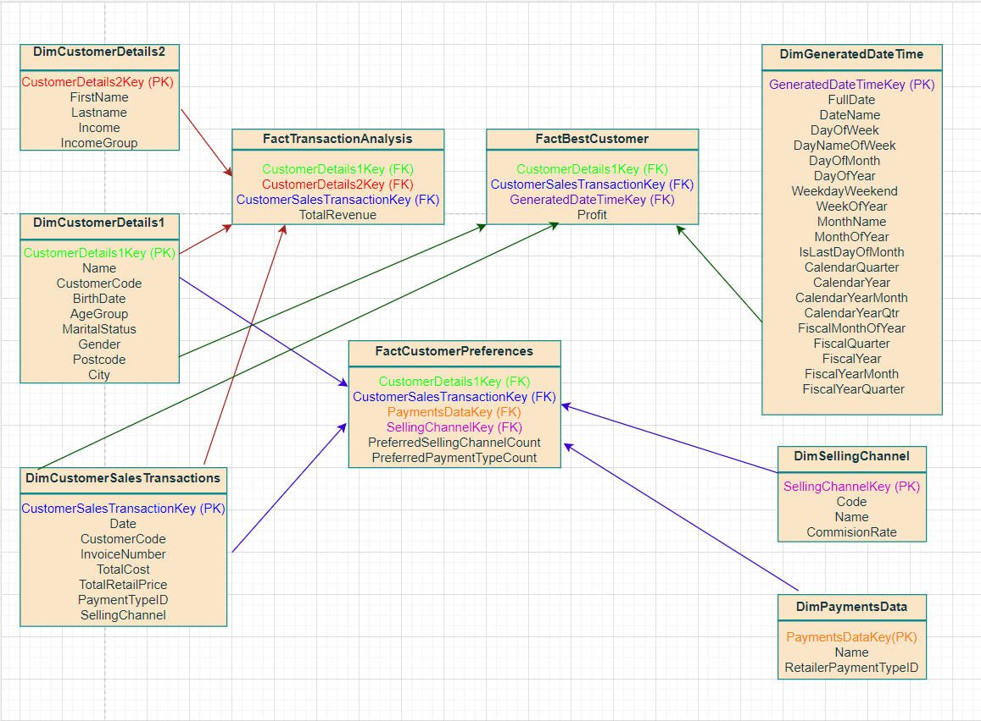

**PART B:**

**As seen in the above proposed design, there are two dimensions used for the customer details which is not feasible as it takes more memory and also increases the overhead on the system so, they are clubbed into one dimension as seen below. The Income and IncomeGroup attributes are used in the DimCustomerDetails1 dimension and FirstName and Lastname can be easily obtained from Name attribute hence, the dimension DimCustomerDetails2 is scrapped and the final design is implemented as shown below.**

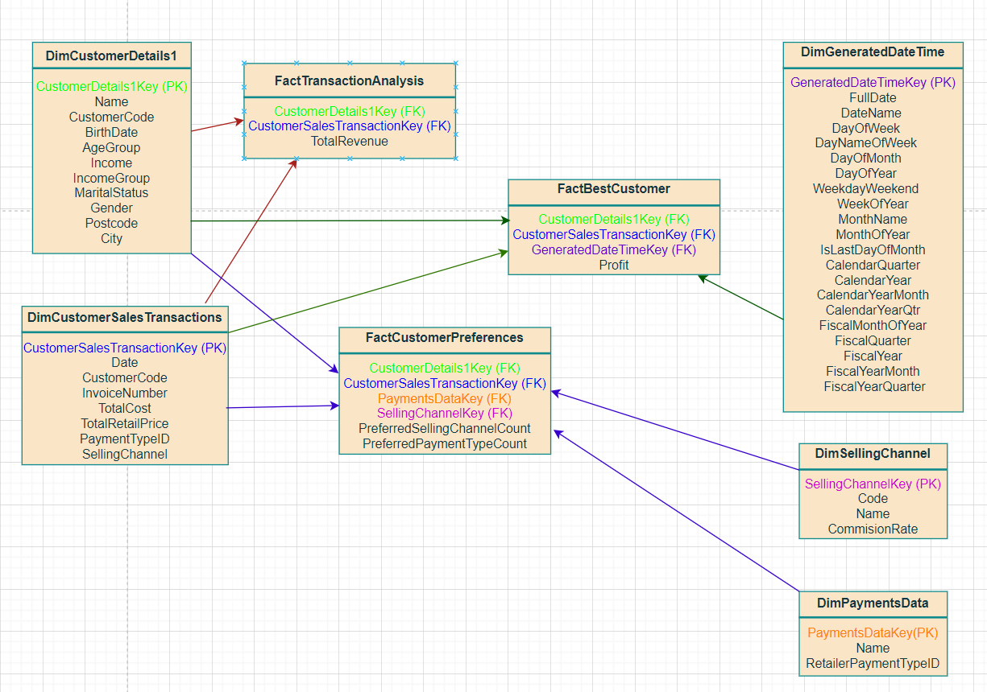

**Fig1. Star Schema for Blue Sky Electronics Online Retailer**

## Create a Relational Database to store dimensions and fact tables using Microsoft SQL Server Management Studio.

* 1. **Create a database.**

The first and foremost step after starting SSMS is to create a database where all the data will be present and the necessary operations will be carried out. Here, a database named cs7079 is created as shown below:

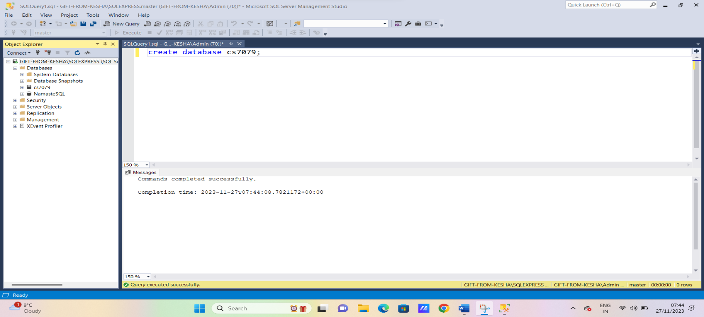

**Fig2. Execution of create database command in SSMS**

As seen in the figure above, the created database cs7079 can be seen at the left under databases.

* 1. **Create dimension tables**

As seen in the star schema in Fig.1 there are 5 dimensions which need to be created. The create table SQL command is used to do so as shown below:

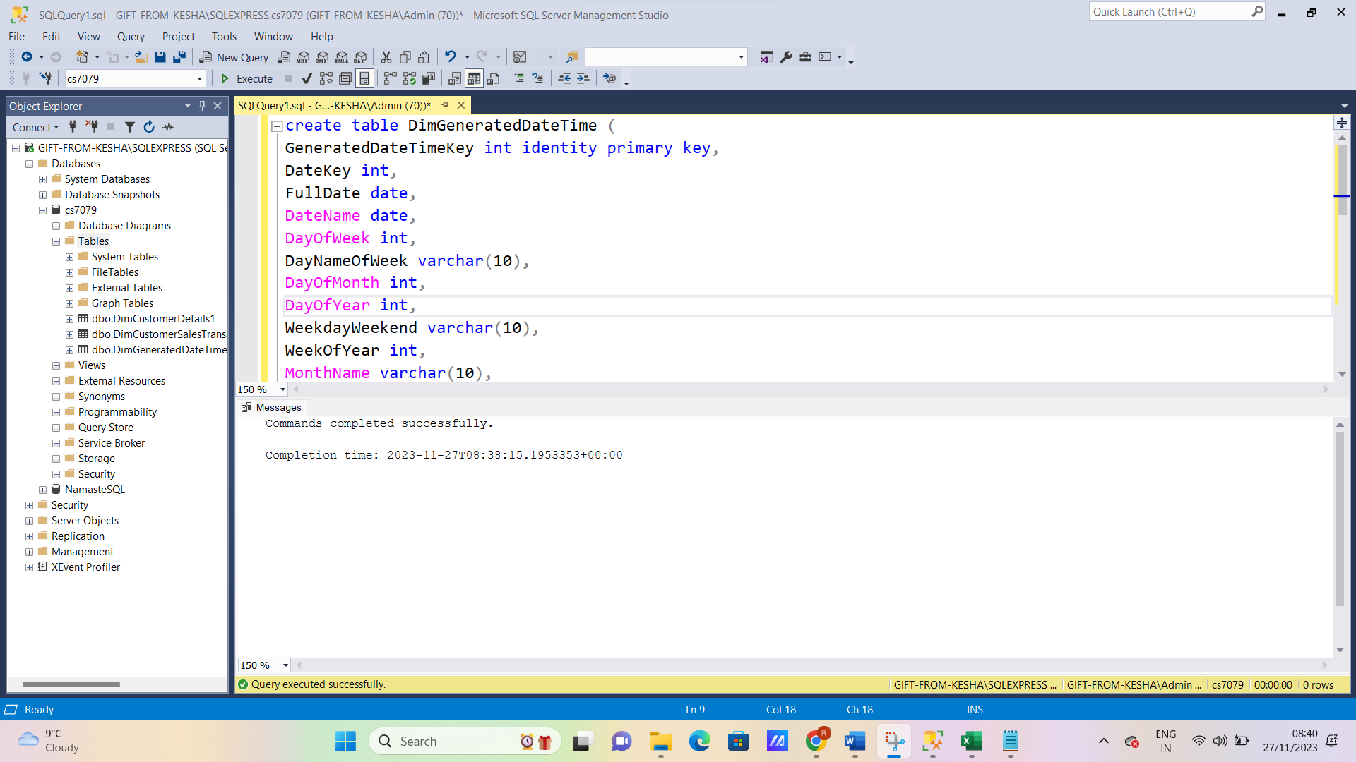

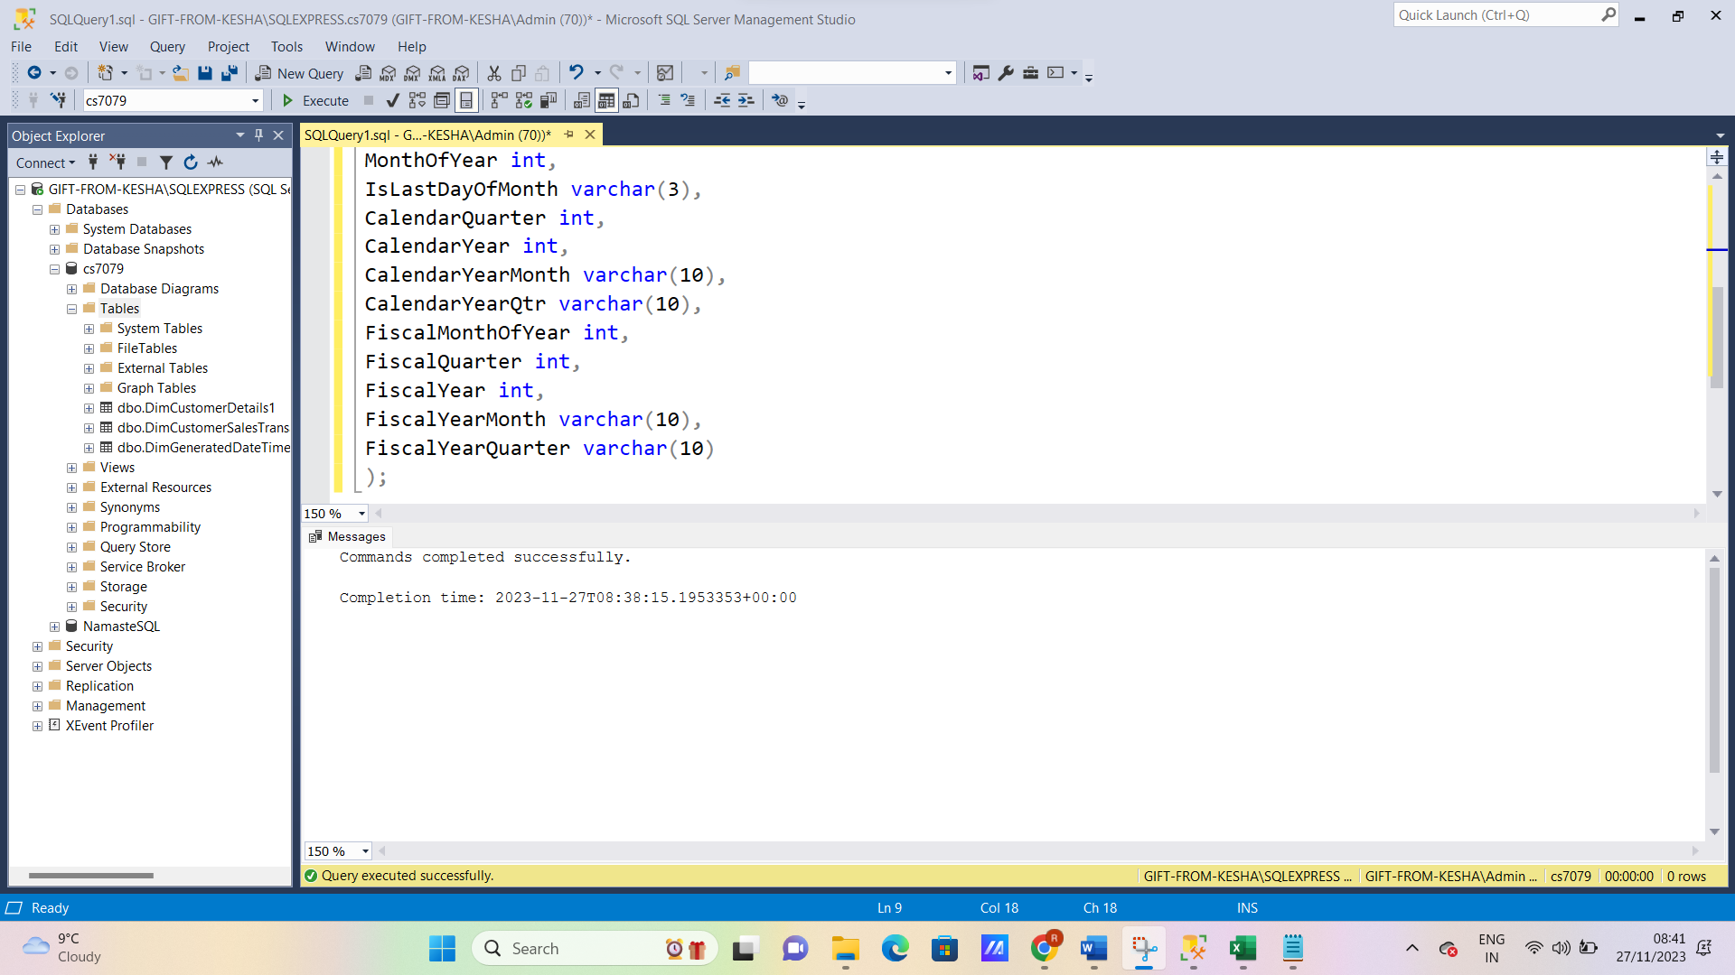**Fig.3 Creating Dimension DimGeneratedDateTime-Part1**

**Fig.4 Creating Dimension DimGeneratedDateTime-Part2**

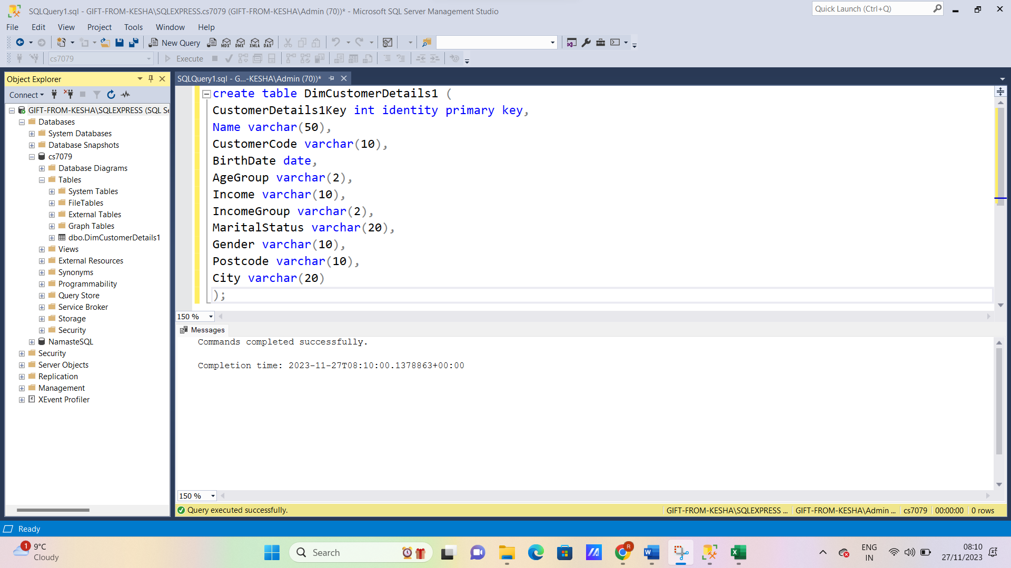

**Fig.5 Creating Dimension DimCustomerDetails1**

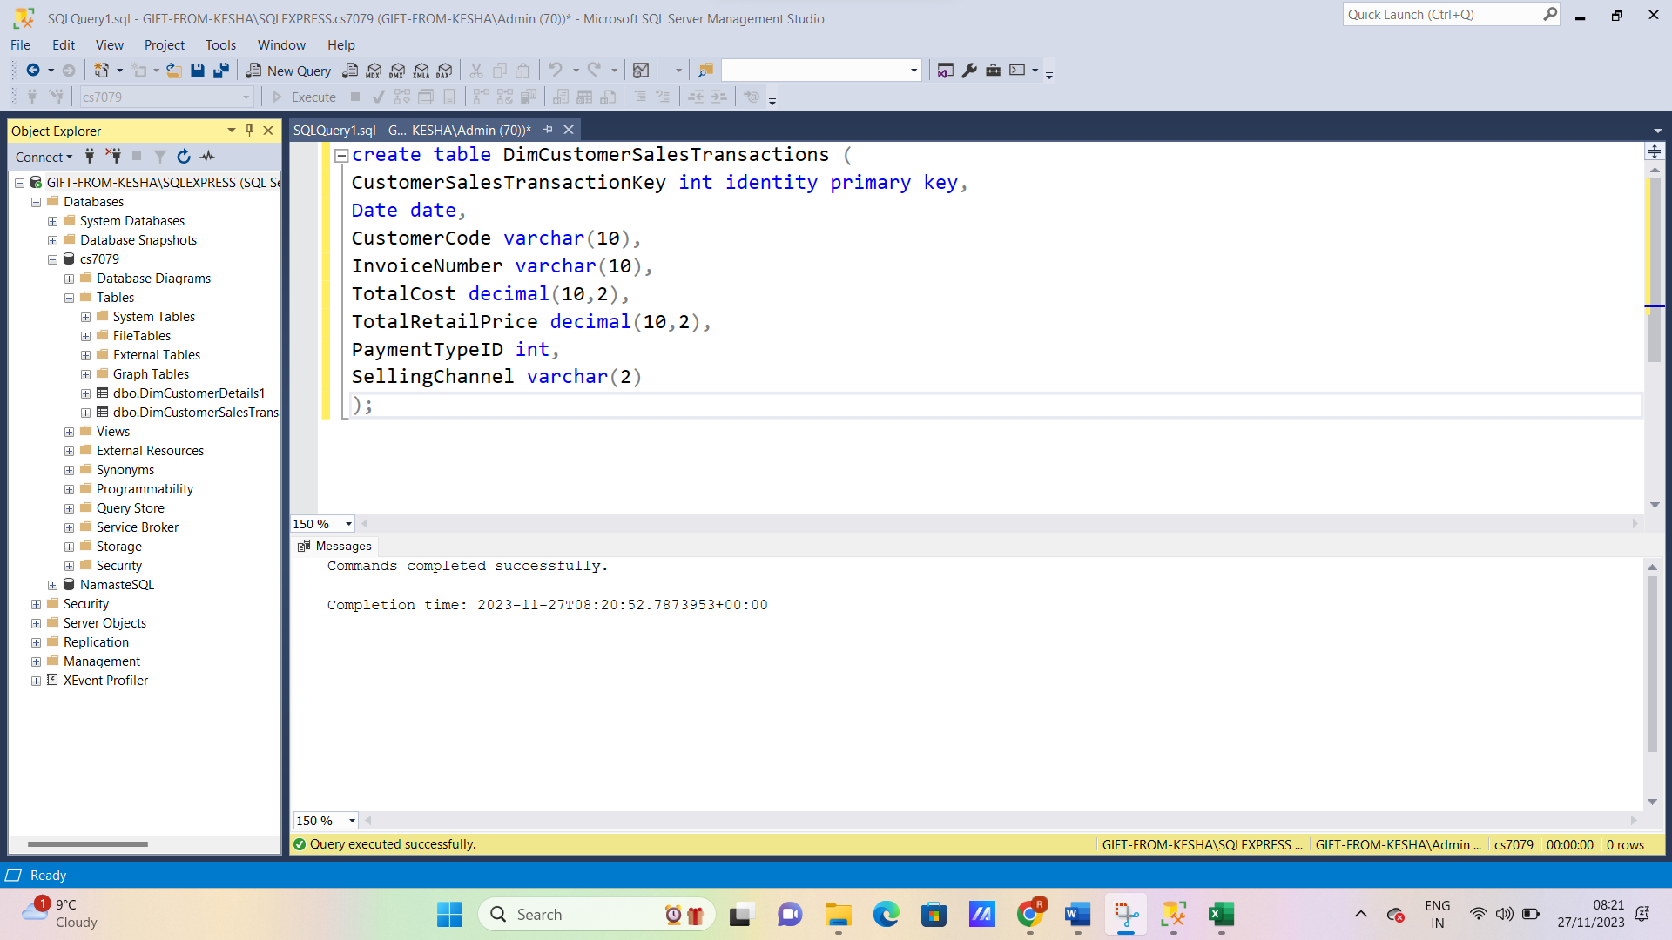 **Fig.6 Creating Dimension DimCustomerSalesTransactions**

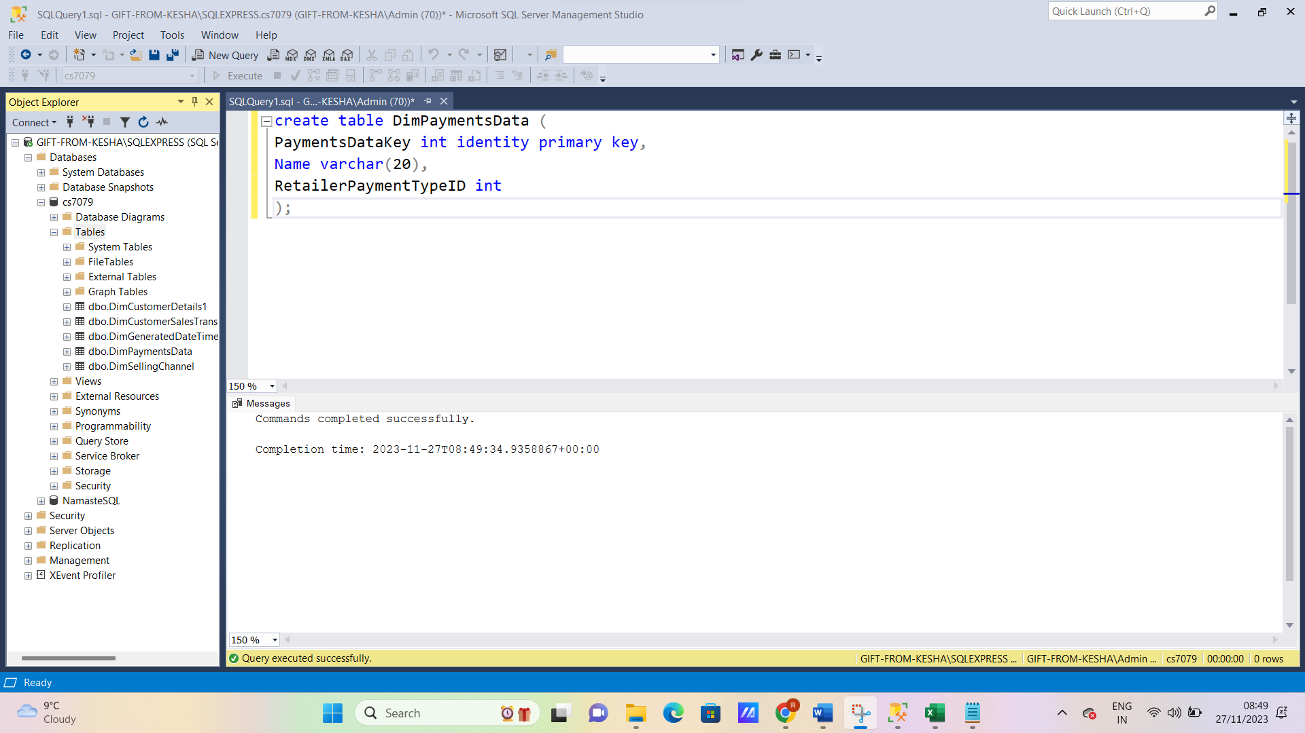

**Fig.7 Creating Dimension DimPaymentsData**

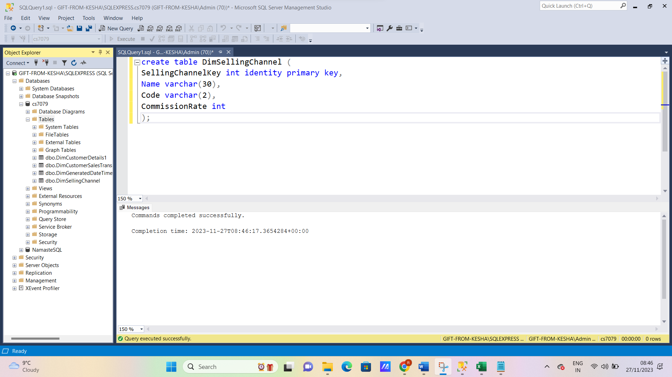

**Fig.8 Creating Dimension DimSellingChannel**

As seen in the above figures all the 5 dimension tables were created which can be viewed to the left under tables.

* 1. **Create fact tables.**

As seen in the star schema, three fact tables are proposed which need to be created using the create command in SQL.

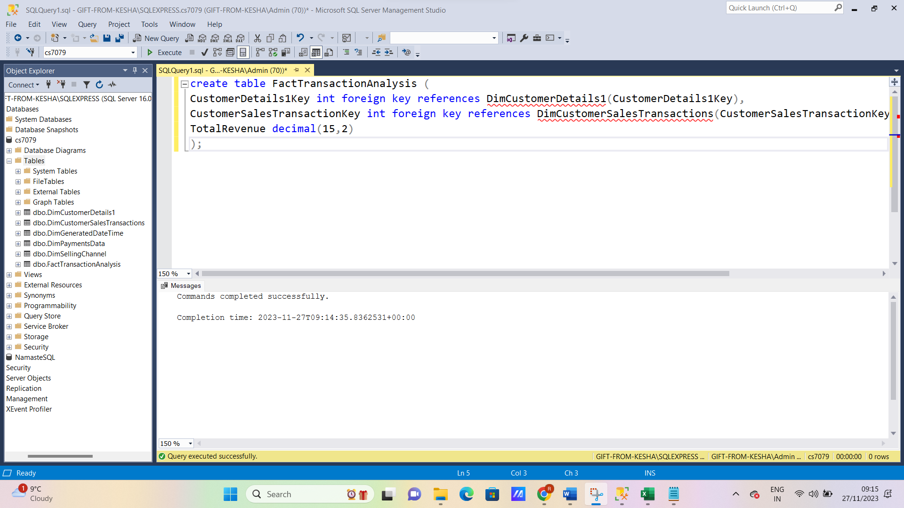

**Fig.9 Creating Fact table FactTransactionAnalysis**

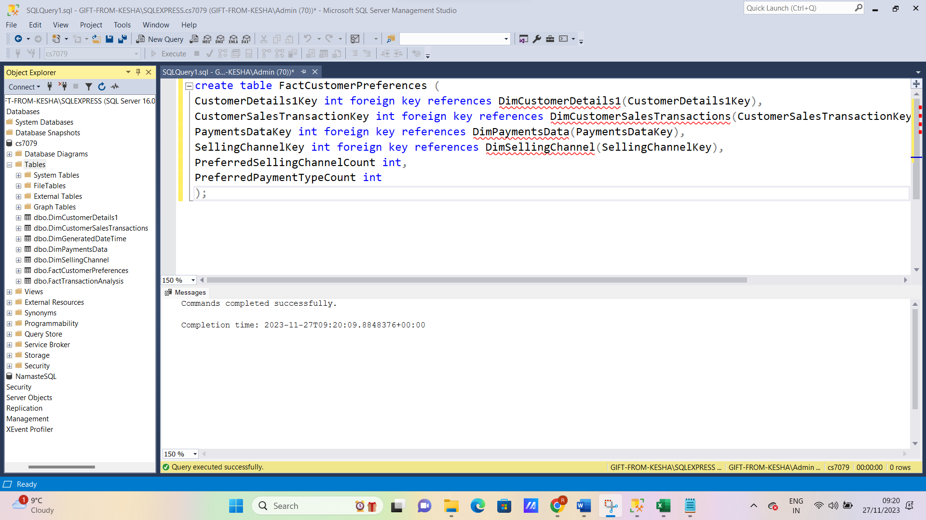

**Fig.10 Creating Fact table FactCustomerPreferences**

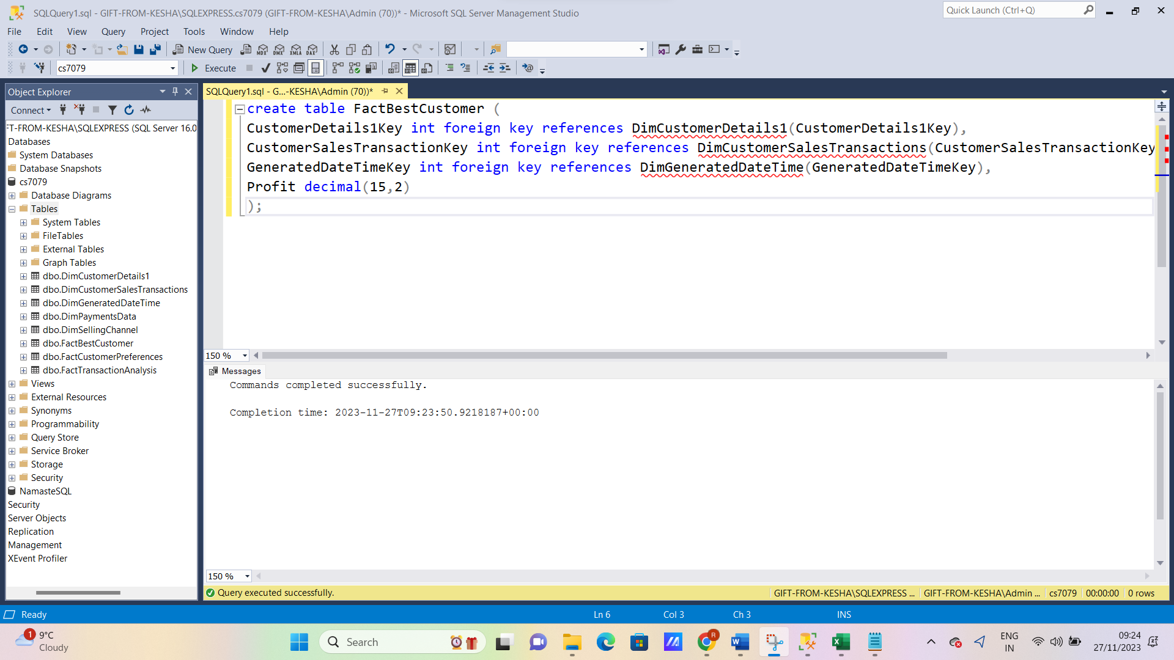

**Fig.11 Creating Fact table FactBestCustomer**

As seen in the above figures, the three fact tables are created which can be viewed under tables to the left.

* 1. **Add appropriate primary keys and foreign keys constraints**

All primary and foreign keys are added at the time of table creation for simplicity. This can be achieved as the star schema was finalized before creating the dimension and fact tables. The appropriate primary and foreign keys were added as follows:

In dimension DimGeneratedDateTime a primary key named GeneratedDateTimeKey is added. This key is an identity auto increment key.

In dimension DimCustomerDetails1 a primary key named CustomerDetails1Key is added. This key is an identity auto increment key.

In dimension DimSalesTransactions a primary key named CustomerSalesTransactionKey is added. This key is an identity auto increment key.

In dimension DimSellingChannel a primary key named SellingChannelKey is added. This key is an identity auto increment key.

In dimension DimPaymentsData a primary key named PaymentsDataKey is added. This key is an identity auto increment key.

In fact table FactTransactionAnalysis two foreign keys named CustomerDetails1Key and CustomerSalesTransactionKey are added. These keys are surrogate keys referencing their respective dimension tables.

In fact table FactCustomerPreferences four foreign keys named CustomerDetails1Key, SellingChannelKey, PaymentsDataKey and CustomerSalesTransactionKey are added. These keys are surrogate keys referencing their respective dimension tables.

In fact table FactBestCustomer three foreign keys named CustomerDetails1Key, GeneratedDateTimeKey and CustomerSalesTransactionKey are added. These keys are surrogate keys referencing their respective dimension tables.

## Populate the implemented data warehouse based on the provided data sources using SQL Server Management Studio.

* 1. **Implement ETL (extract, transform, and load) processes to populate dimension tables.**

ETL has four major sub processes:

* Extracting the data from source systems.
* Loading the data into the staging area.
* Cleaning and transforming.
* Loading the cleaned and transformed data into data warehouse.

Initially, the first step is to start the import and export wizard in SSMS. This can be done using tasks under the database which is used currently. The next step is to choose the source from where the data needs to be extracted as seen in the figure below:

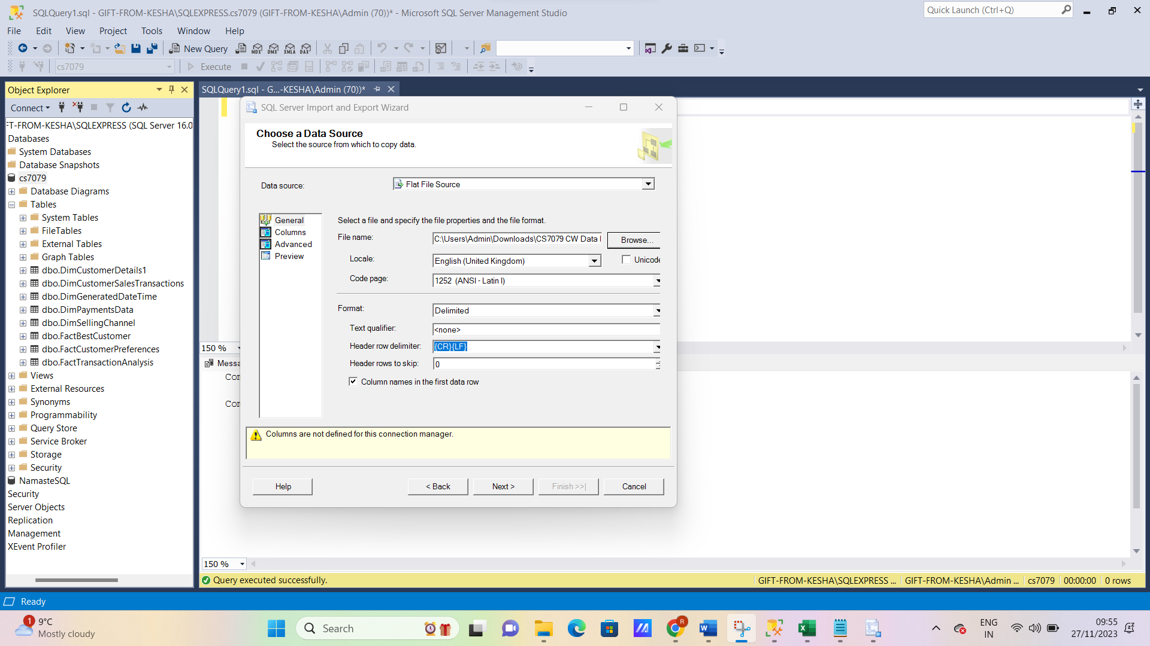

**Fig.12 Choosing the flat file data source to extract data**

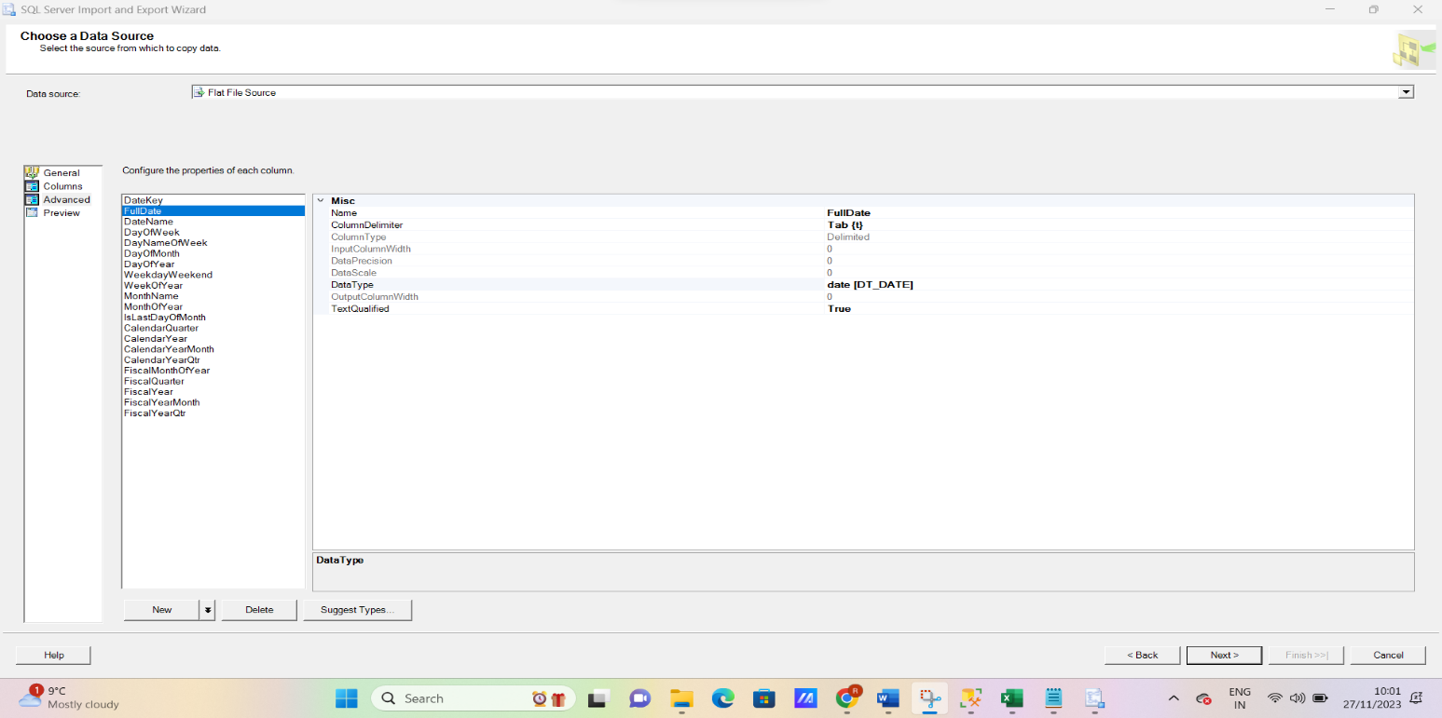The flat file provided includes the data which needs to be populated which is the GeneratedDateTime.txt in this case. Then the destination to where the data will be loaded needs to be selected which is the DimGeneratedDateTime in this case.

**Fig.13 Changing data types of the attributes of the table**

After the source and destination are selected, the data types of the attributes need to be changed appropriately as they all are set to STRING by default as seen in the above figure. After the data types are changed, the next step is to edit the mappings which involves mapping the columns of the source data to columns of the destination data.

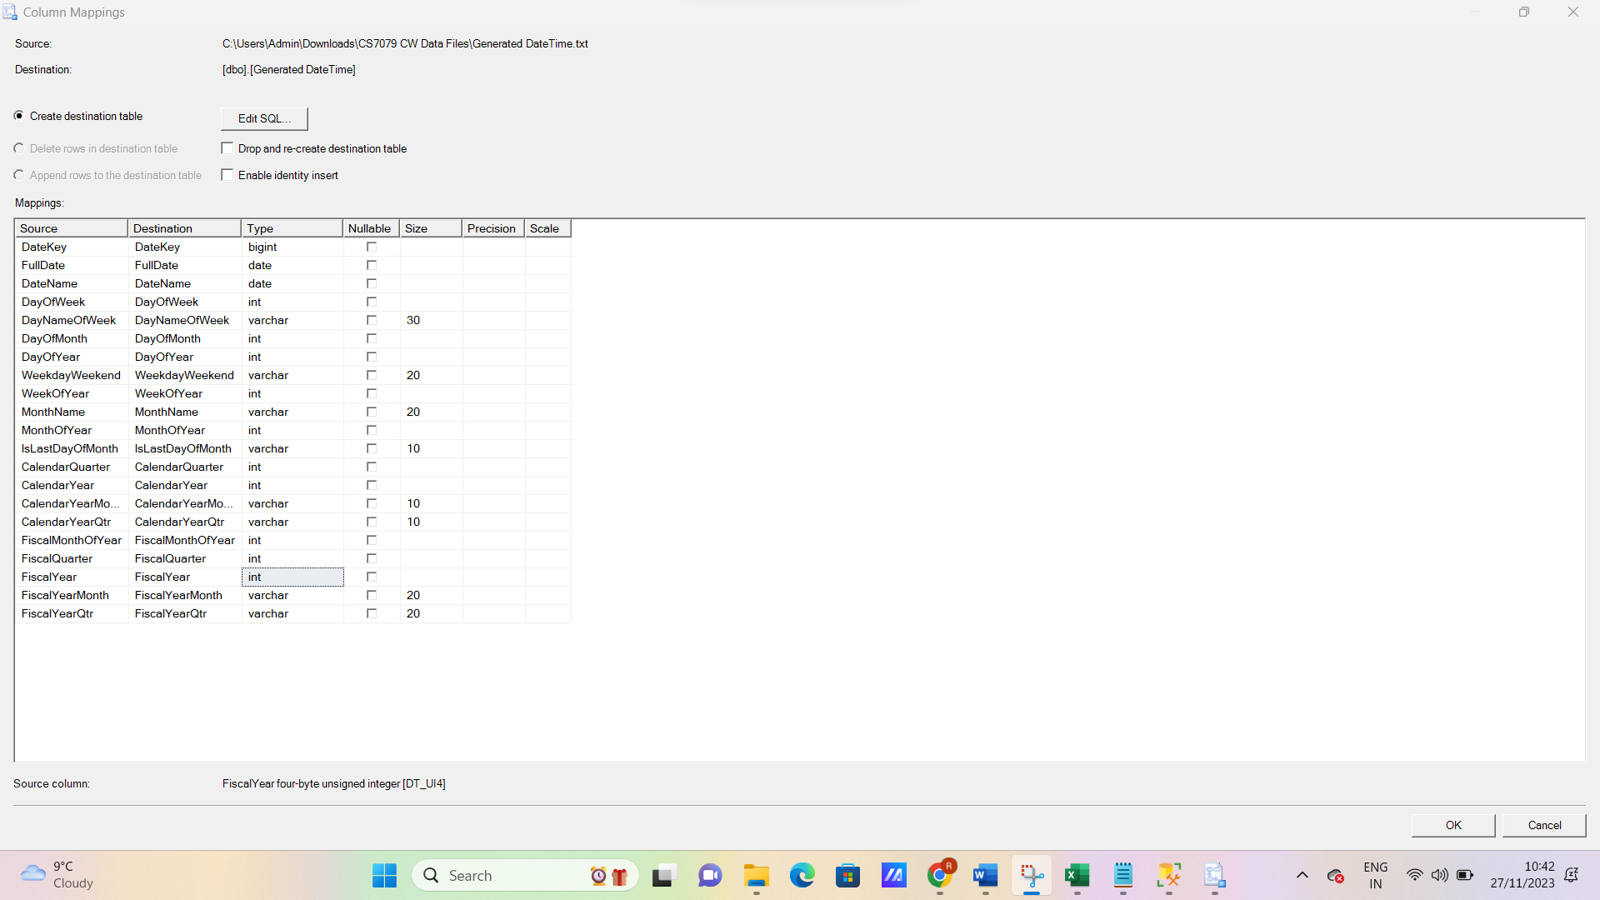

**Fig.14 Editing mappings of the columns of the dimension**

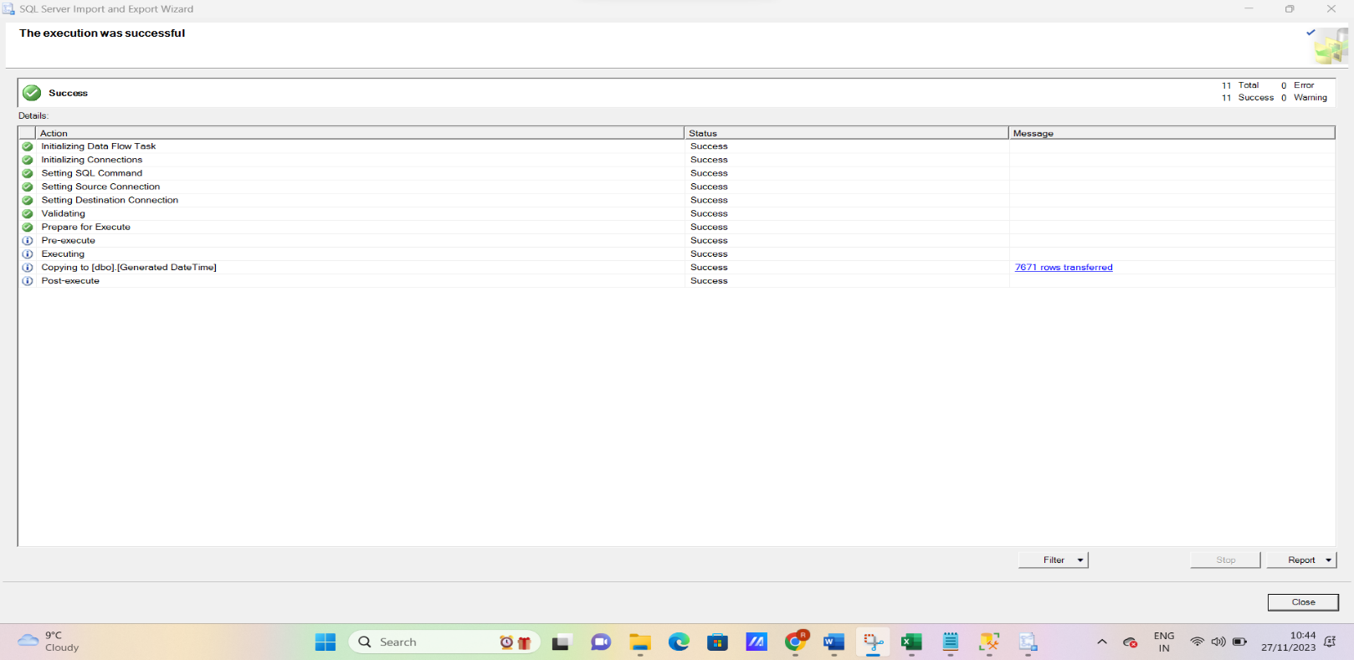After editing the mappings, the process of importing data is executed and if the data types and mappings of the source and destination data match, it runs successfully as seen in the figure below:

**Fig.15 Successful population of the dimension DimGeneratedDateTime**

Similarly, the dimensions DimSellingChannel, DimPaymentsData and DimCustomerSalesTransactions are populated using the same procedure explained above.

The dimension DimCustomerDetails1 is also populated using the same procedure however, after populating it when the table data was seen, it gave the following result:

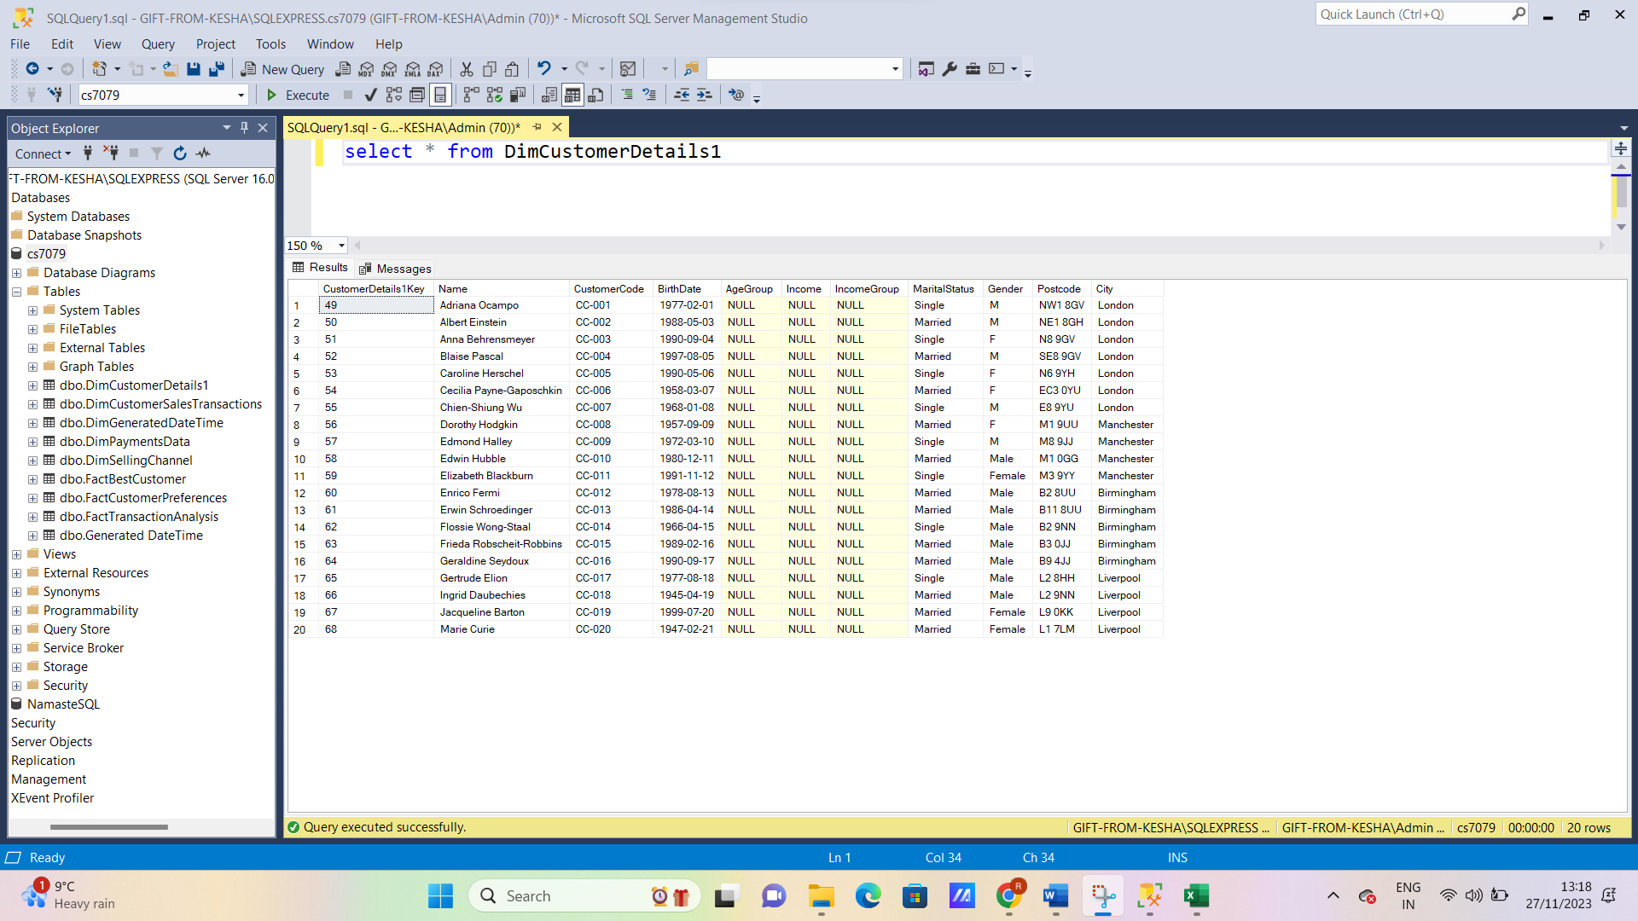

**Fig.16 NULL values in dimension CustomerDetails1**

As seen above there are null values for columns AgeGroup, Income and IncomeGroup. This is because these columns do not exist in the given data. But Customer income details were provided in a separate text file. Now, Income column was populated from the CustomerDetails2.txt file provided. This was achieved using the standard population procedure. So, now two null valued columns were left to be filled. This was achieved using SQL queries as IncomeGroup was determined by Income column and AgeGroup was determined using the BirthDate column. The SQL queries used to achieve this are as follows:

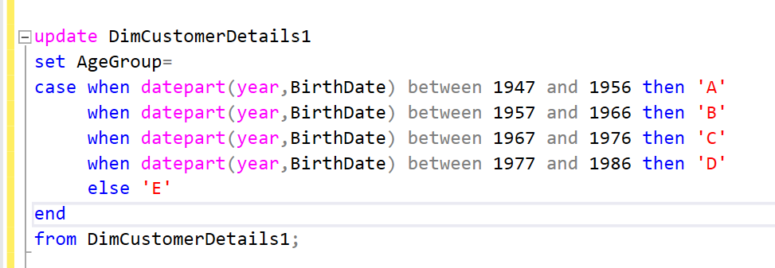

**Fig.17 SQL query used to populate AgeGroup column of dimension DimCustomerDetails1**

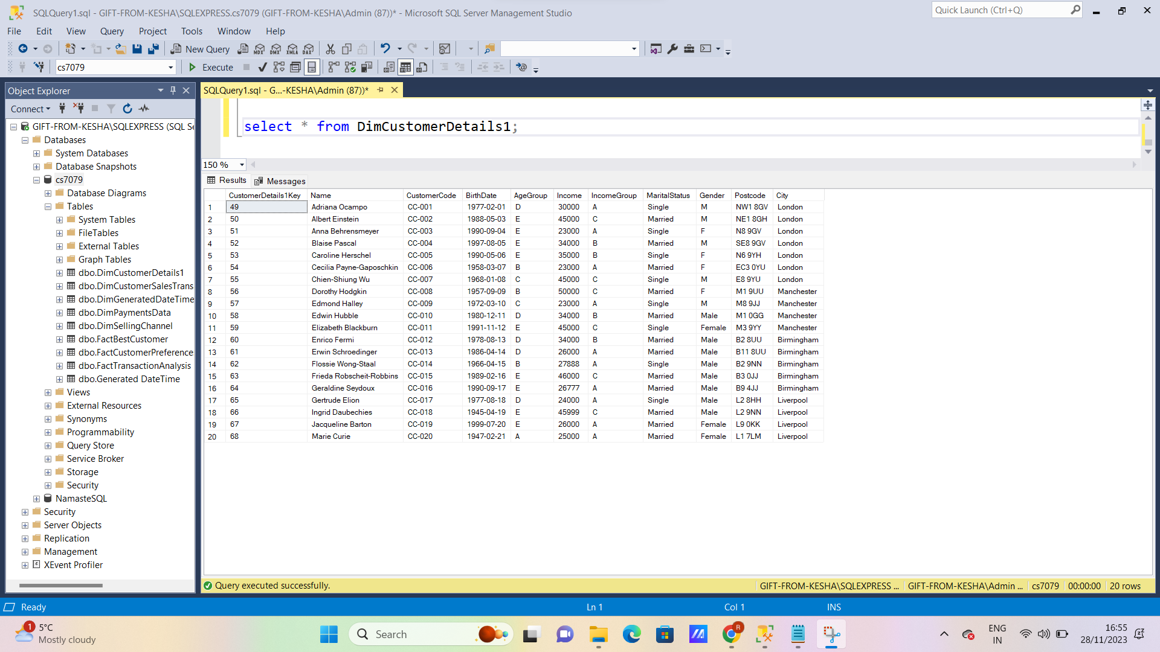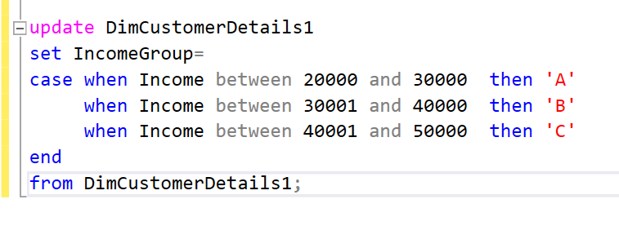**Fig.18 SQL query used to populate IncomeGroup column of dimension DimCustomerDetails1**

**Fig.19 No Null values in Dimension CustomerDetails1**

As seen above, the dimension CustomerDetails1 was successfully populated and hence, all dimensions were populated using ETL process.

* 1. **Implement ETL (extract, transform, and load) processes to populate a fact table.**

Populating fact tables is much more complicated and different than populating dimension tables. Initially, a staging area needs to be created where all the lookup tables from the dimensions will be created.

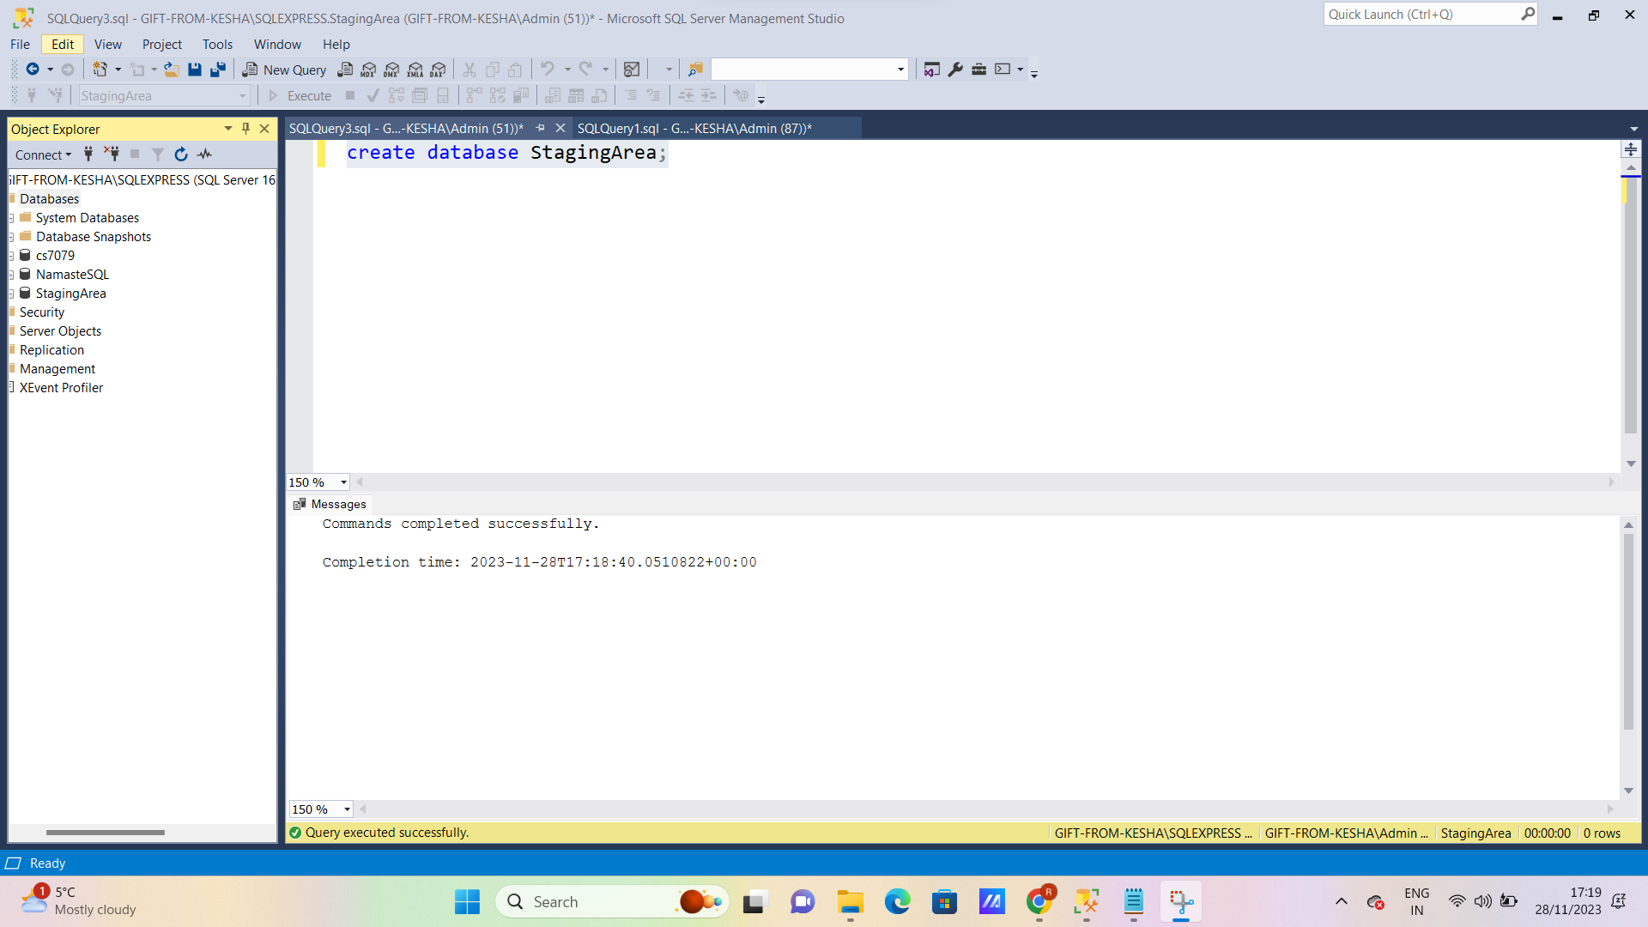

**Fig.20 Create a Staging Area**

Now, lookup tables need to be created which will be used to populate the fact tables. These lookup tables will be extracted from the data warehouse populated earlier. The SQL commands to create lookup tables is as follows:

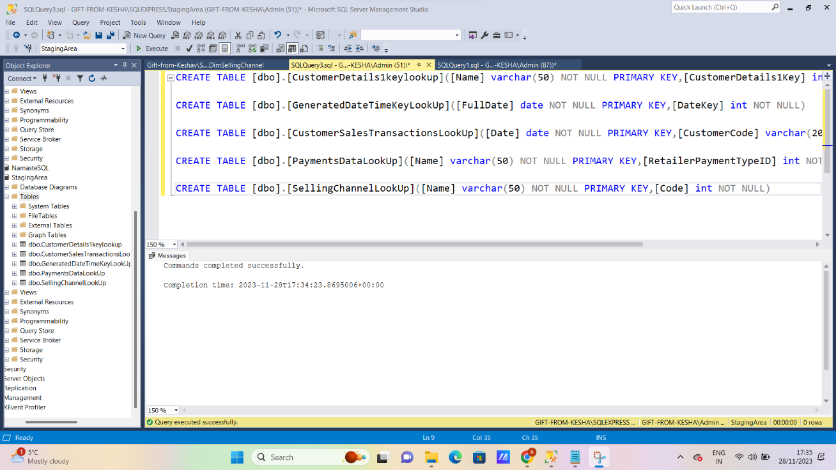**Fig.21 Creating lookup tables**

It is important to note that the primary key constraints should be assigned carefully after viewing the populated data so that no duplicates are found there or else it may give errors later. These lookup tables are populated the same way as the dimension tables were populated using the ETL process. This involves extracting the data from the populated warehouse, transforming the data types, editing mappings and then loading the data into the lookup tables.

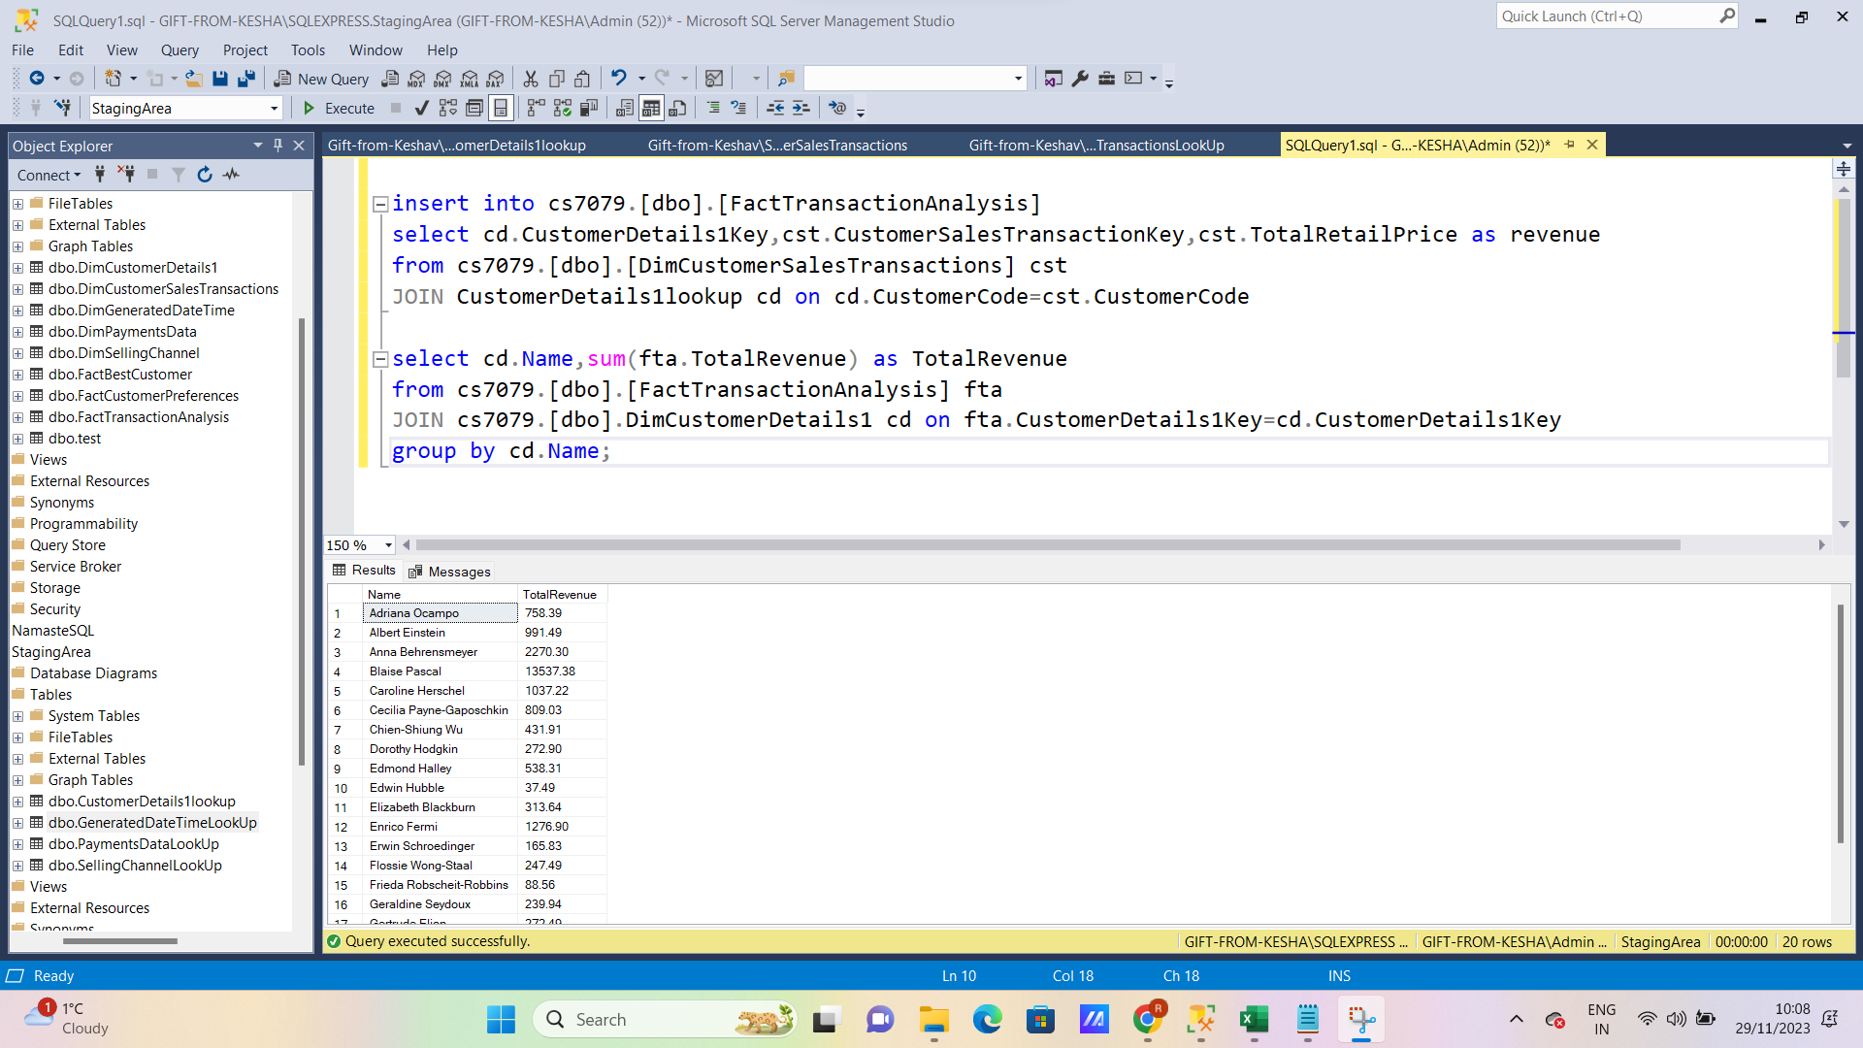After populating them, the fact tables are populated using the following SQL queries:

**Fig.22 Populating fact table FactTransactionAnalysis**

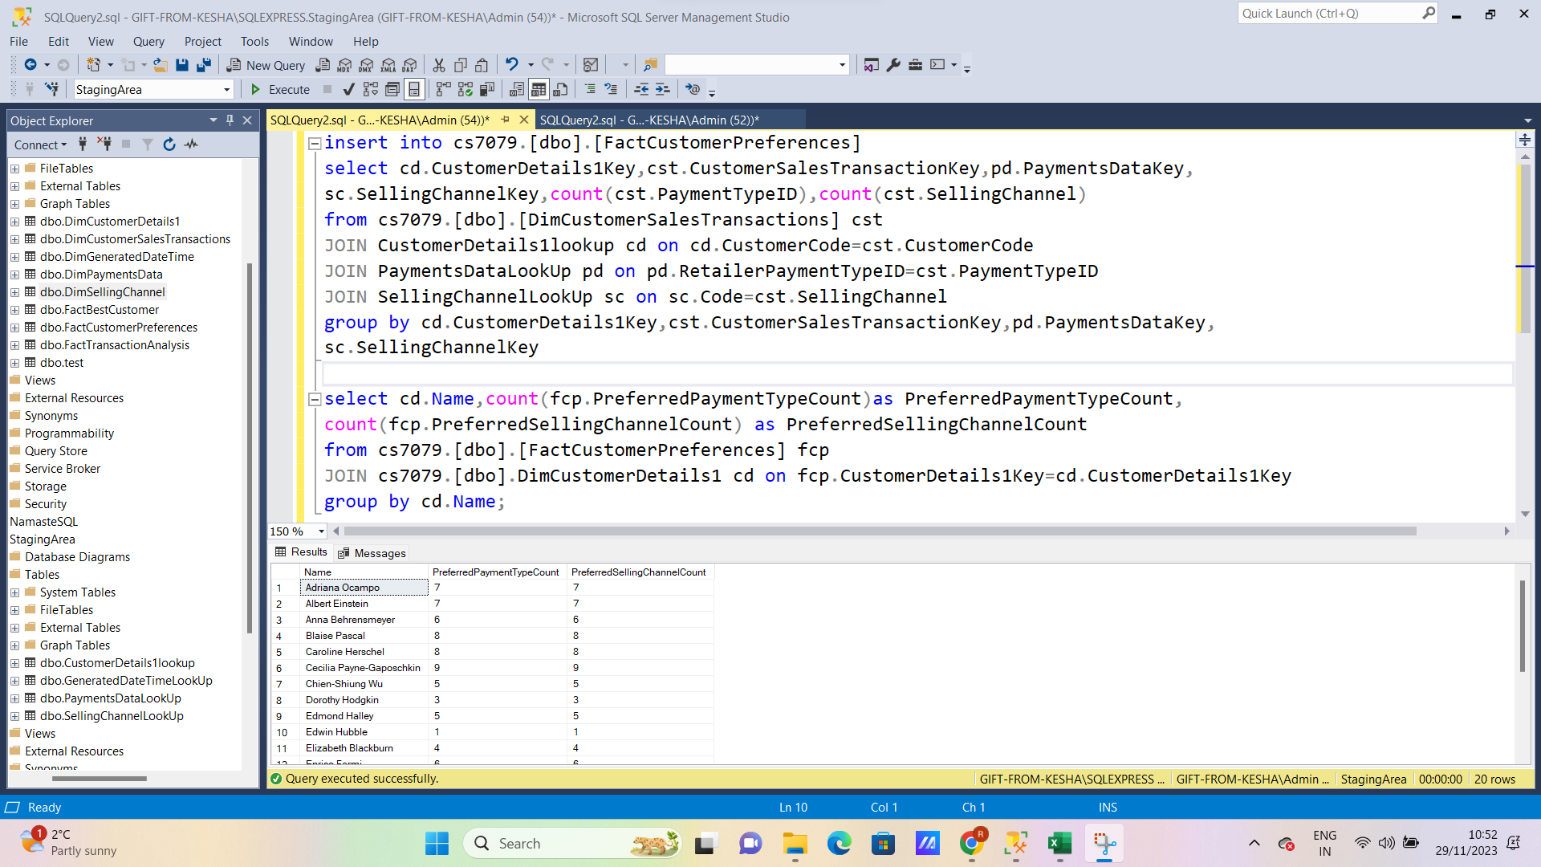**Fig.23 Populating fact table FactCustomerPreferences**

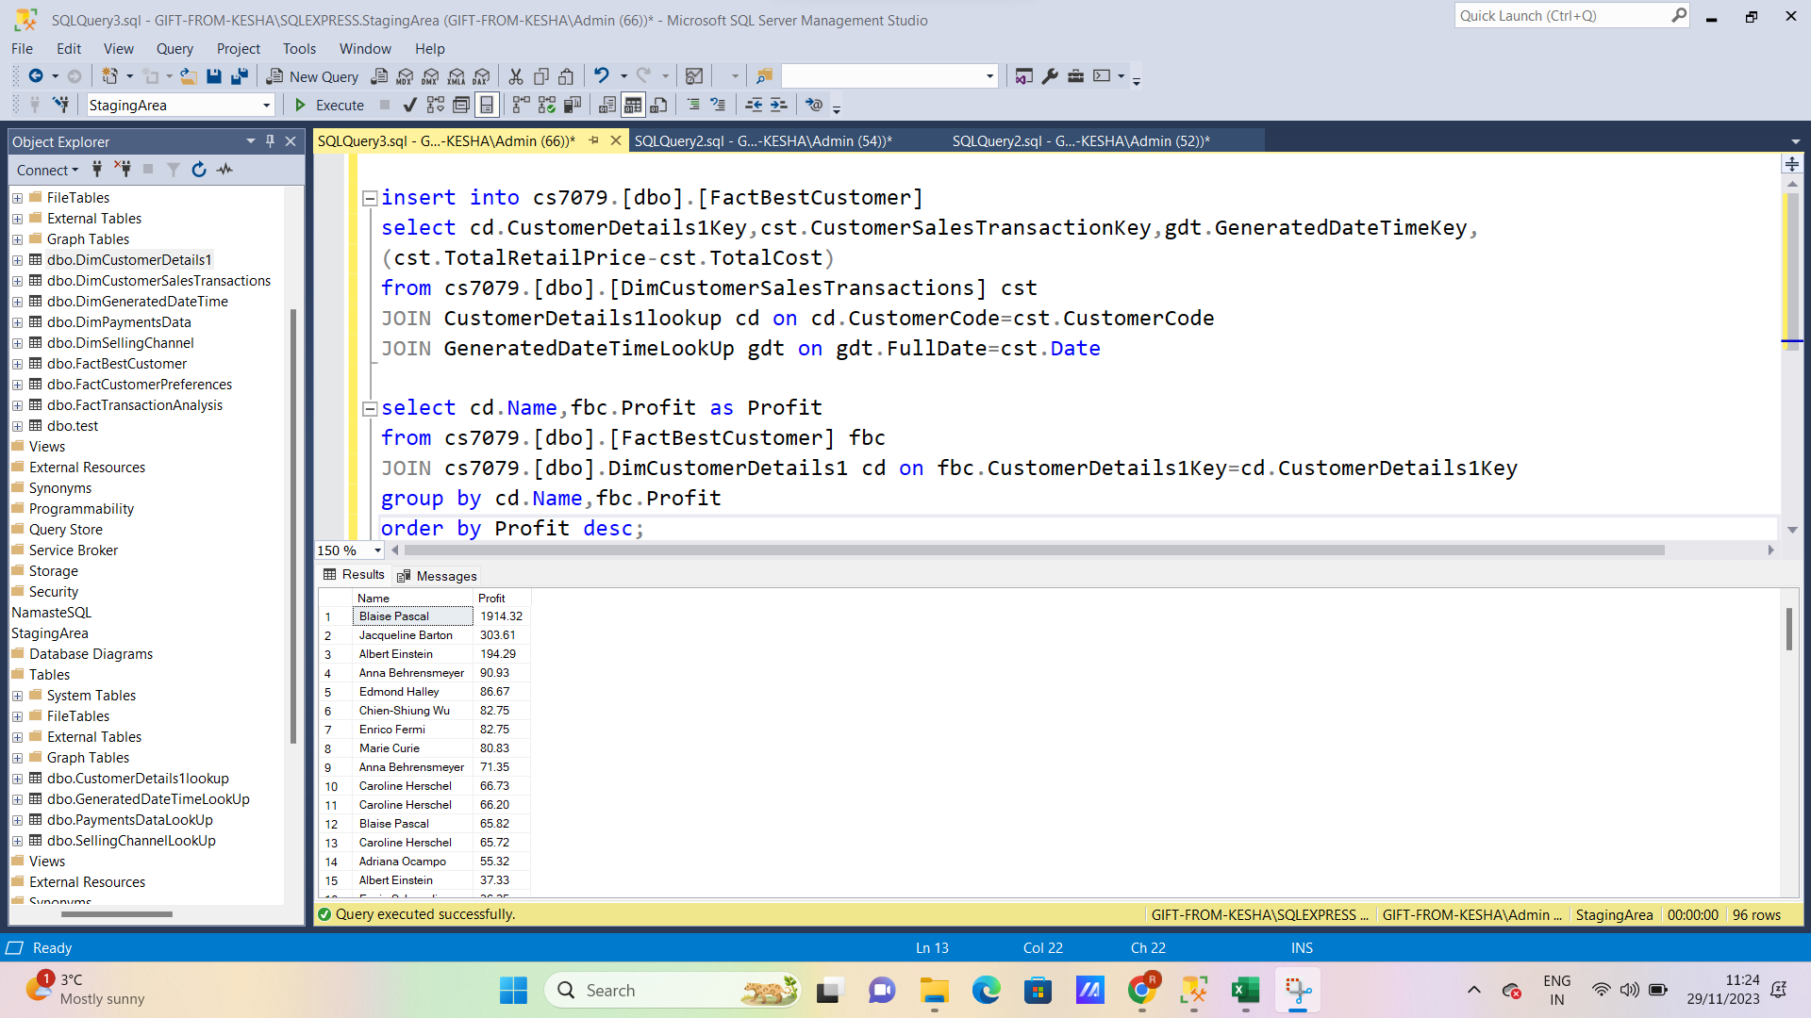

**Fig.23 Populating fact table FactBestCustomer**

**Initially, the fact tables are populated using JOIN SQL command on the already populated dimensions and the concerned lookup tables. Then SQL queries are used to visualize the measures of the fact tables which are helpful in reporting analysis as seen in the above three figures**.

Thus, all three fact tables were successfully populated using the ETL process.

## Migrate test data from the data warehouse to an Apache Hadoop platform for further analysis of Big Data using Hortonworks Data Platform (HDP)

* 1. **Populate the data warehouse database with some test data.**

This task is already done in the above steps. The dimensions and the fact tables are fully populated using the ETL processes.

* 1. **Export the data warehouse database data into an external data file.**

After populating all tables, the data needs to be exported to an external data file. This is achieved using the SSMS Import/Export wizard. This tool was used earlier but for importing data and here it will be used to export the data. As a sample fact table FactTransactionAnalysis is chosen to be exported as shown below:

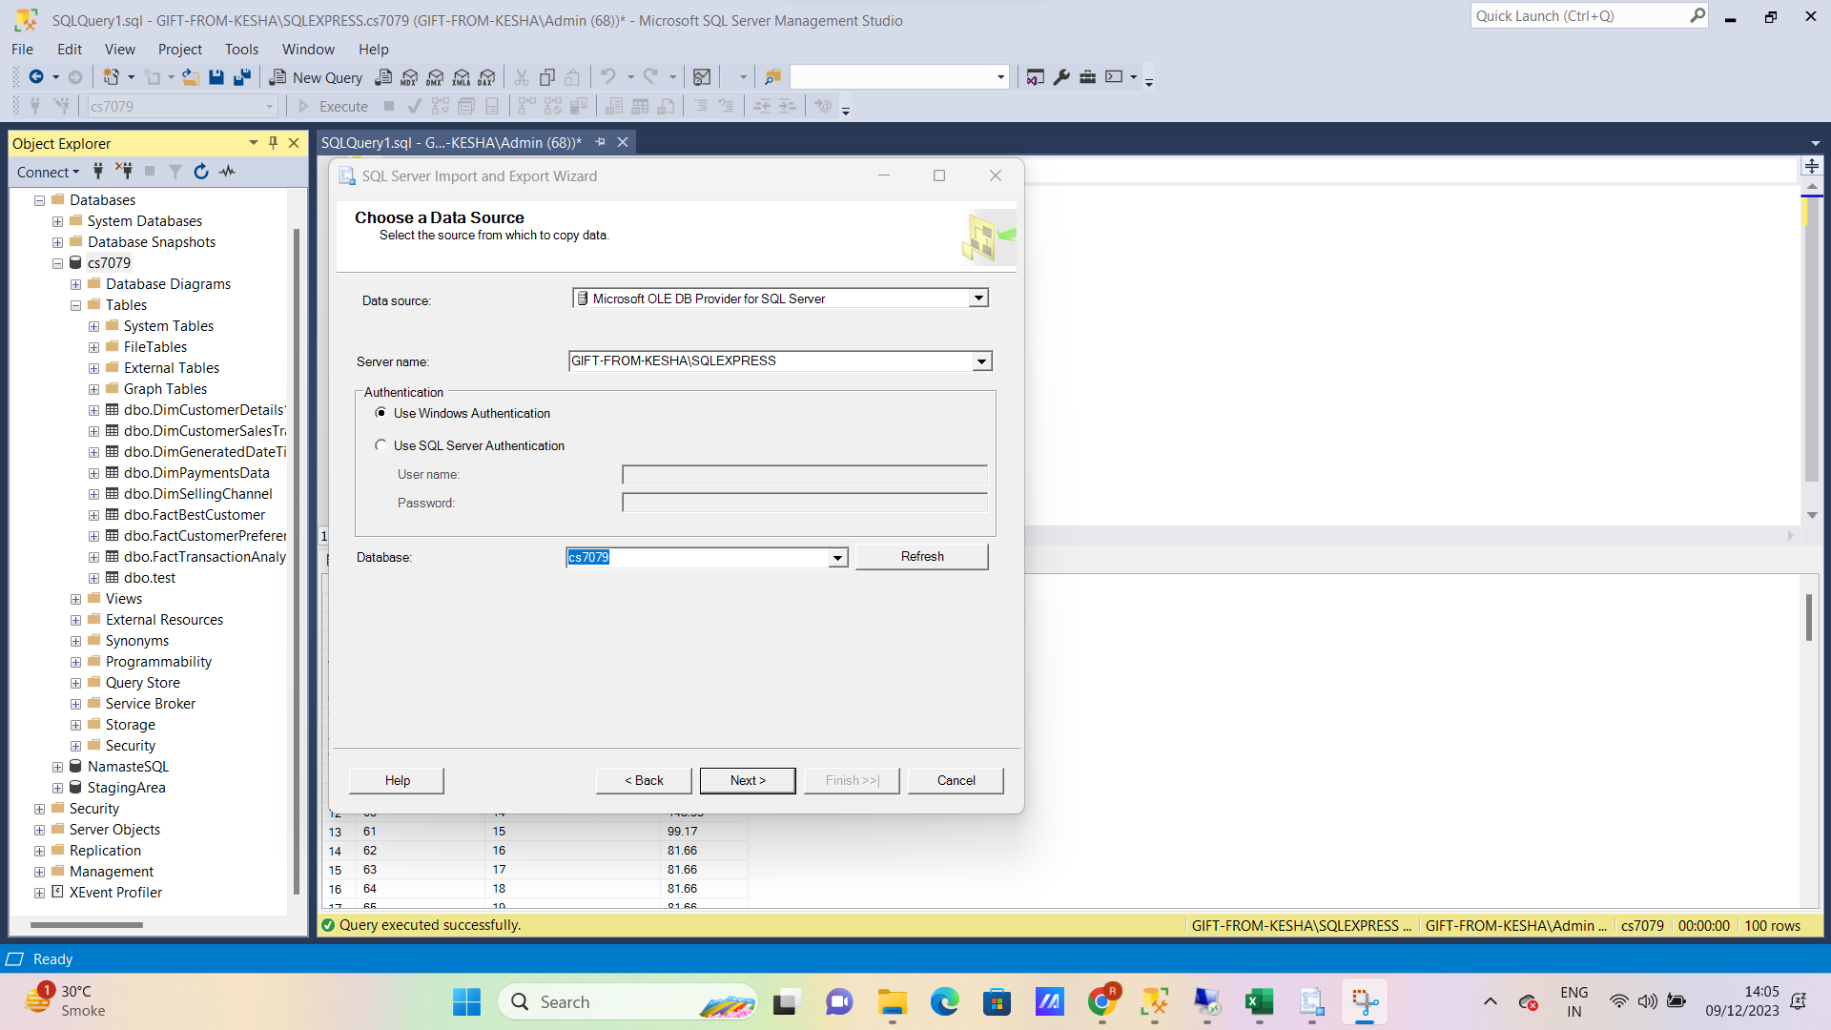

**Fig.24 Choosing the data source to be exported**

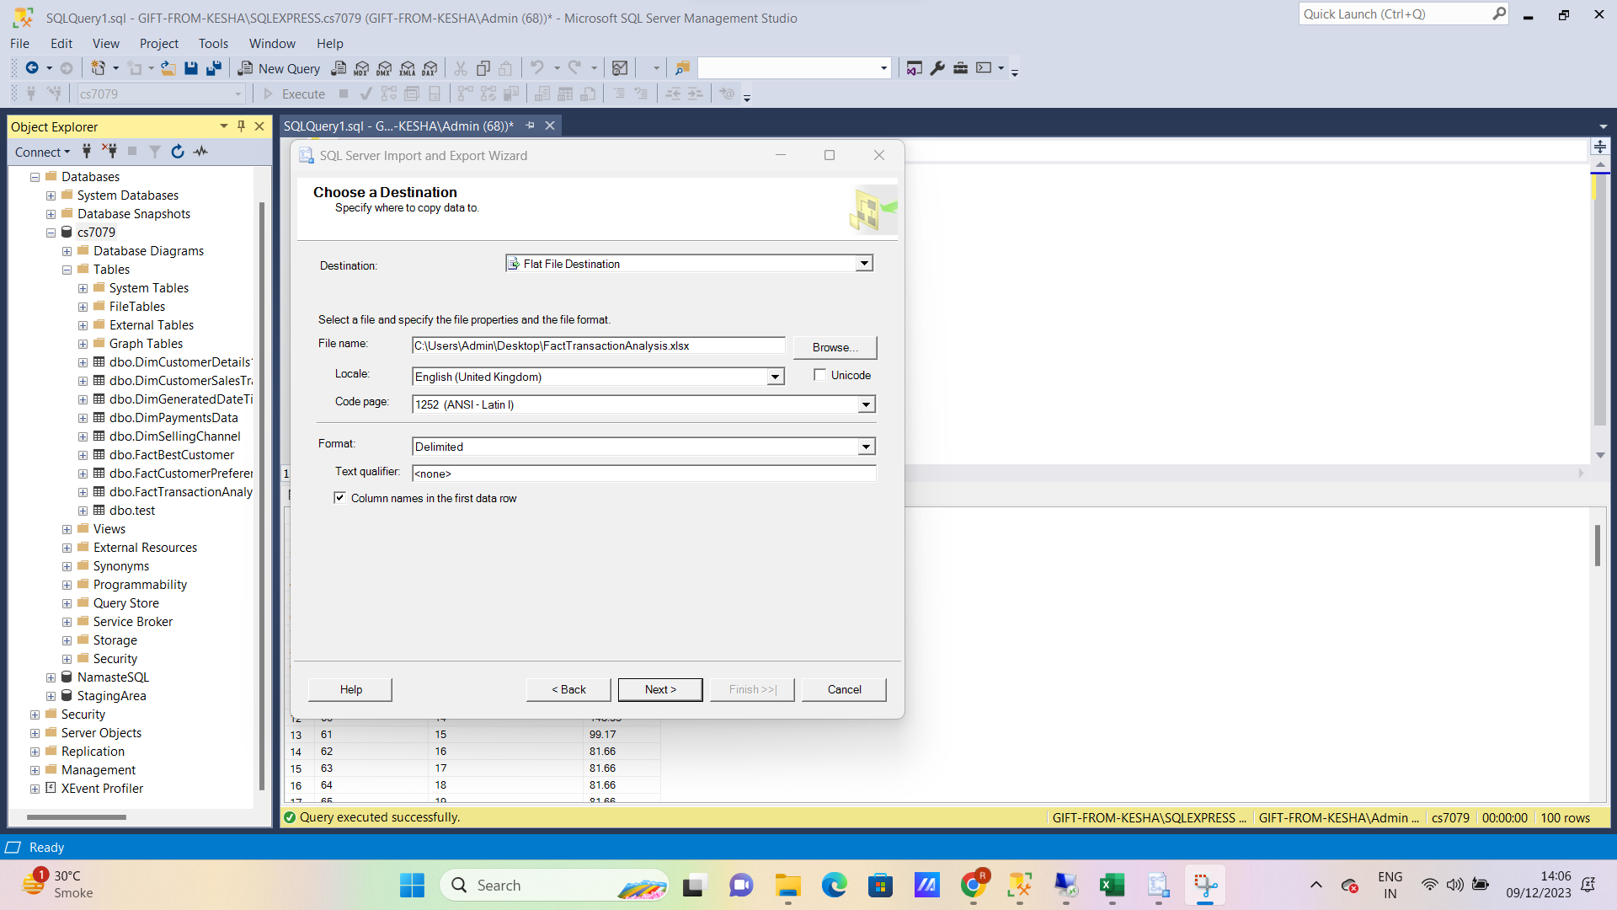The next step is to choose the destination where the data will be exported. A flat file is chosen for this purpose as seen below:

**Fig.25 Choosing the destination where the data will be exported**

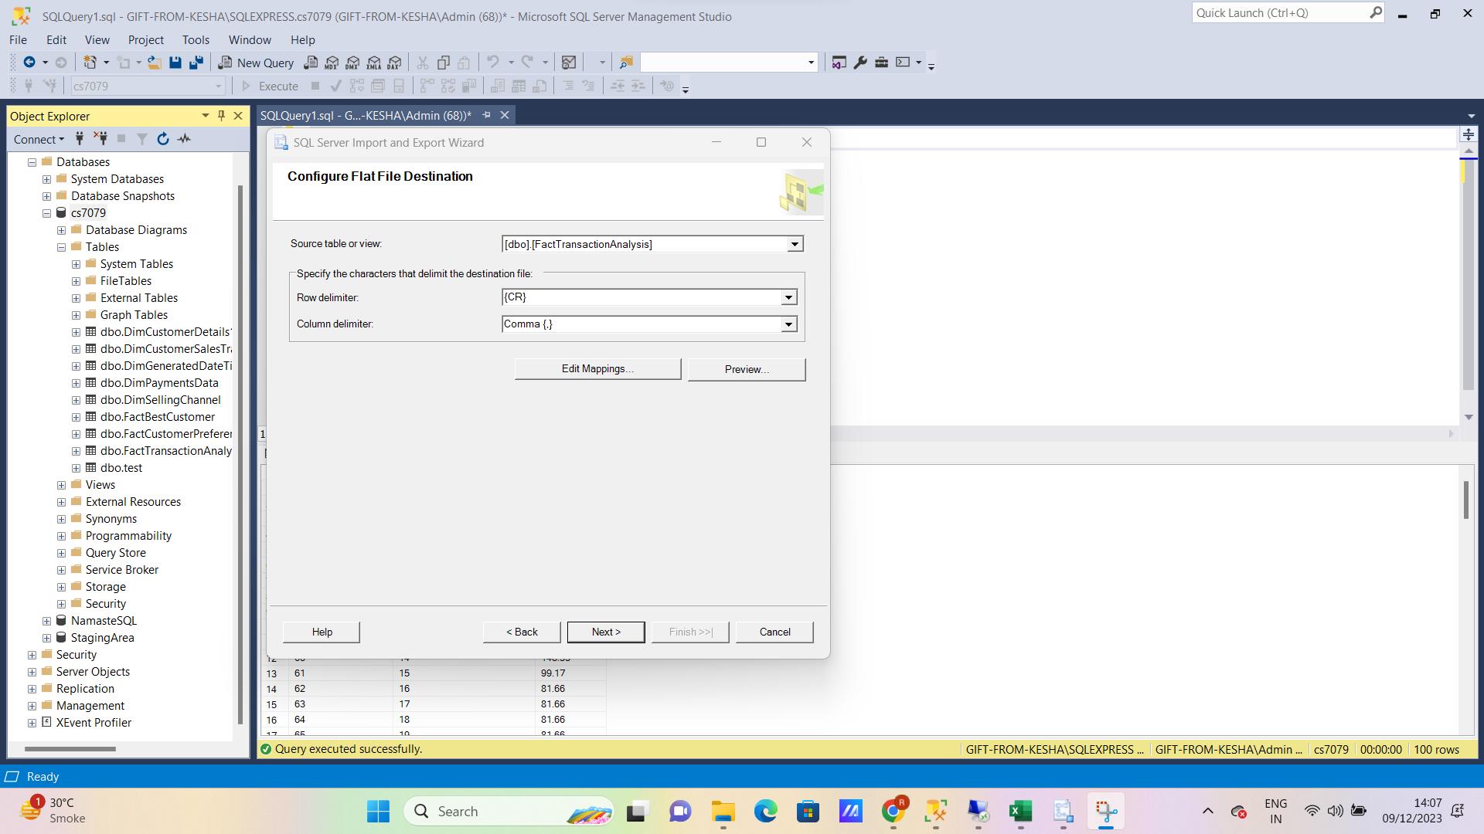The fact table FactTransactionAnalysis is chosen to be exported as seen below:

**Fig.26 Choosing the fact table FactTransactionAnalysis to be exported**

The next step is to edit the mappings and export the data to the destination file the same way as done earlier while importing data. The export was completed successfully as seen below:

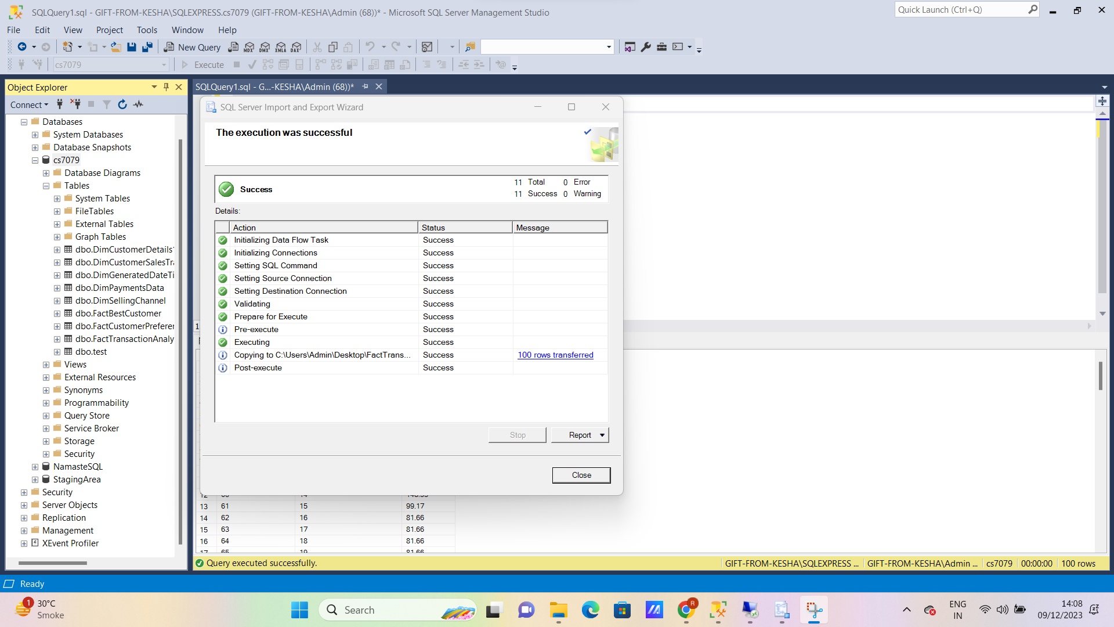

**Fig.27 Successful completion of data export**

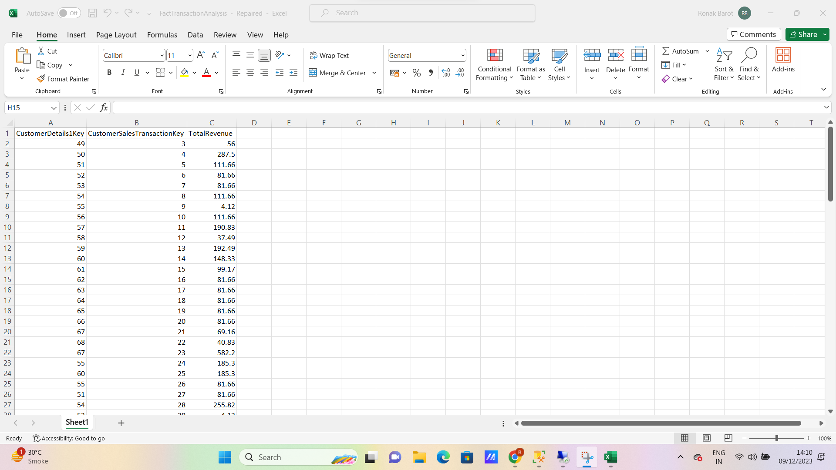The exported flat file was opened to check whether the data was exported correctly and the following result was obtained:

**Fig.28 The exported flat file**

Hence, the data was successfully exported as seen above.

* 1. **Migrate the data file from the file system to Apache HDFS.**

The data file was then migrated to Apache HDFS using the following steps:

* The flat file was initially downloaded on the virtual machine.
* Then the docker environment was initialized on the virtual machine which was already preinstalled on it.
* The Ambari environment was initialized by connecting to the localhost:1080.
* By clicking on Files View, a folder named tmp was located.
* Inside tmp, a new folder called data-22036660 was created.
* 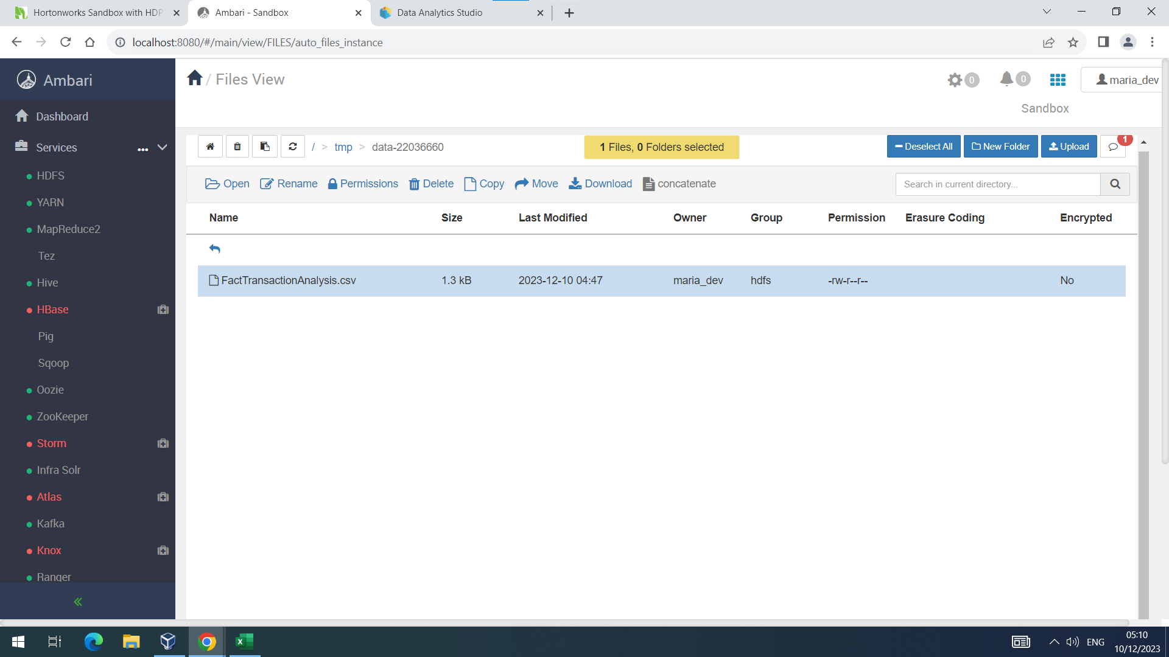Inside data-22036660, the downloaded flat file was uploaded using the upload button which can be seen in the figure below:

**Fig.29 Uploading the migrated flat file to Apache HDFS**

After uploading the flat file, the permissions of the file need to be changed in a way that it should be writable. Hence, the write permissions need to be ticked blue to perform manipulations on the data file as seen below:

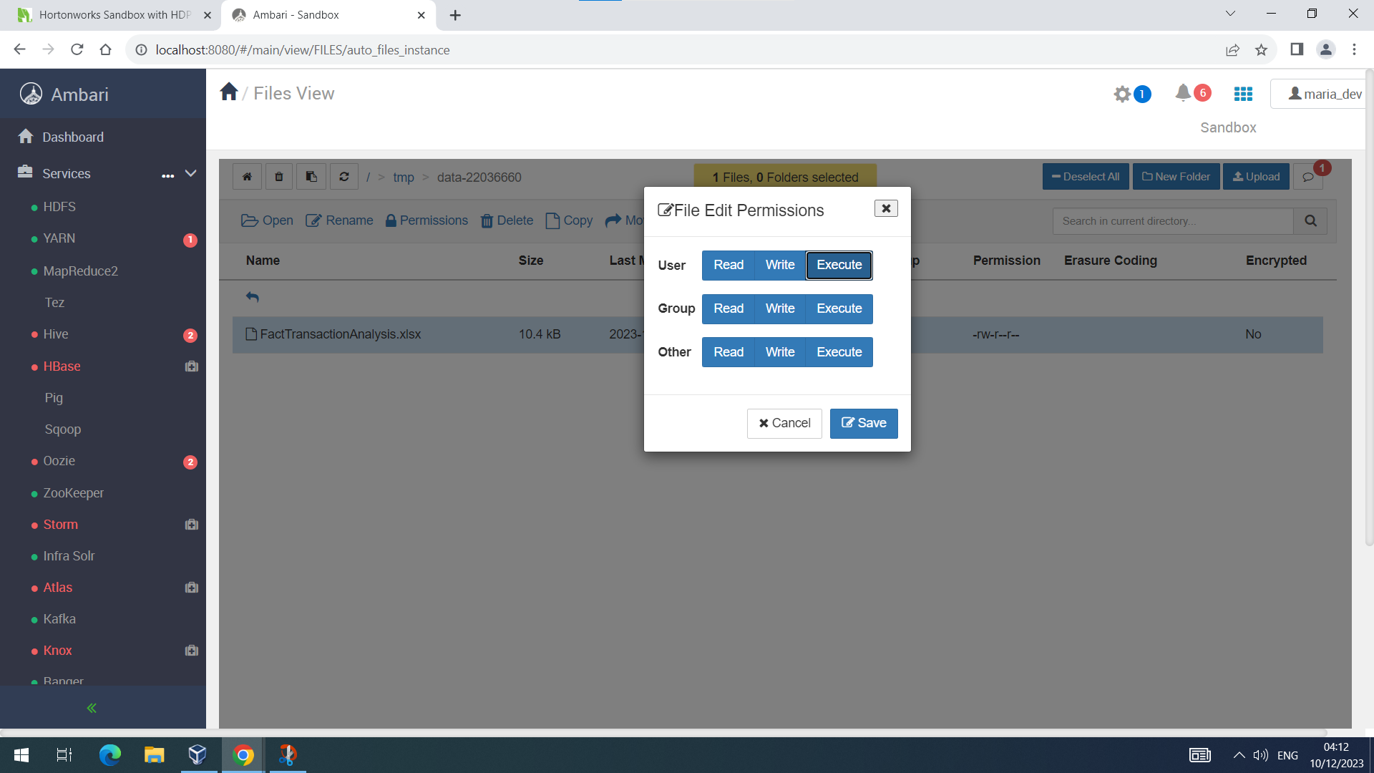

**Fig.30 Setting permissions to make the file writable**

Hence, the flat file has been successfully migrated to the Apache HDFS environment.

* 1. **Create a suitable data structure for loading the data file into HIVE**

The following procedure was followed to create a suitable data structure for loading the data file into HIVE:

* The flat file was initially downloaded on the virtual machine.
* Then the docker environment was initialized on the virtual machine which was already preinstalled on it.
* The Ambari environment was initialized by connecting to the localhost:1080.
* By clicking on Files View, a folder named tmp was located.
* Inside tmp, a new folder called data-22036660 was created.
* Inside data-22036660, the downloaded flat file was uploaded using the upload button which can be seen in the figure below:



**Fig.31 Uploading the migrated flat file to Apache HDFS**

After uploading the flat file, the permissions of the file need to be changed in a way that it should be writable. Hence, the write permissions need to be ticked blue to perform manipulations on the data file as seen below:



**Fig.32 Setting permissions to make the file writable**

Now, the data analytics studio is started by connecting to sandbox-hdp.hortonworks.com:30800.

The first step here is to create to temporary table called temp_facttransactionanalysis. This is pretty similar to creating tables in SQL as seen below:

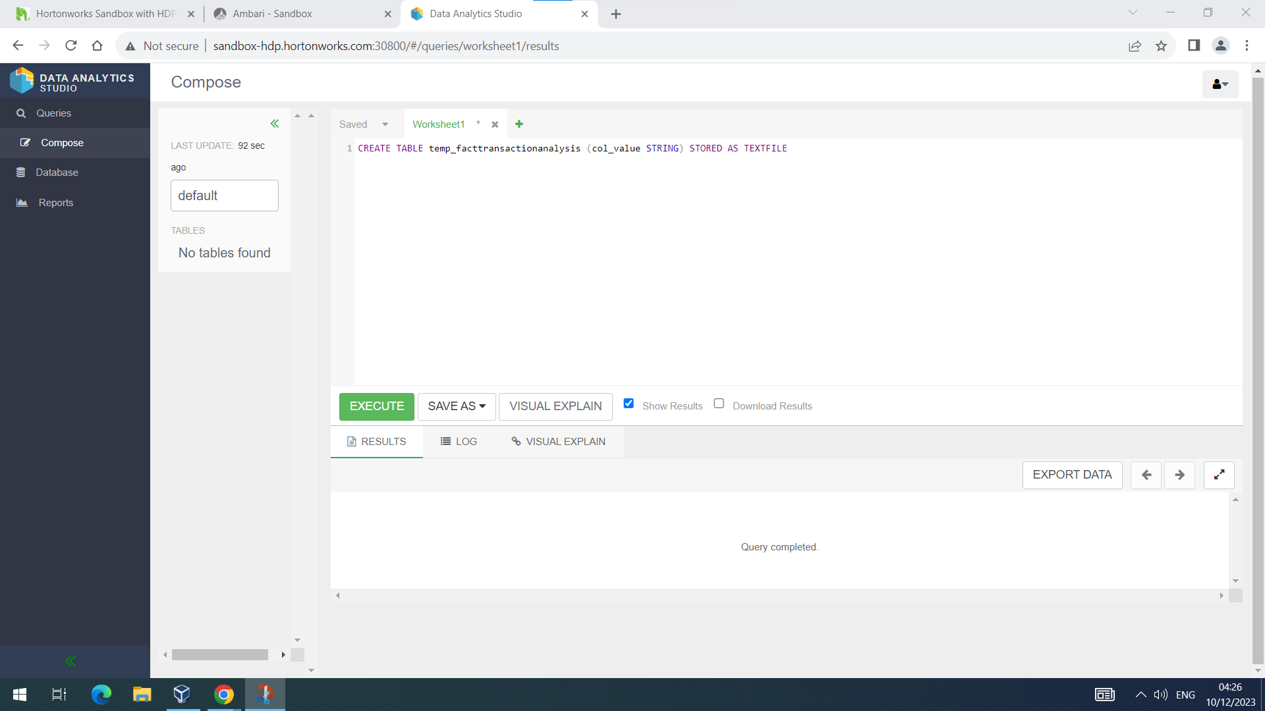**Fig.33 Create table temp_facttransactionanalysi**s

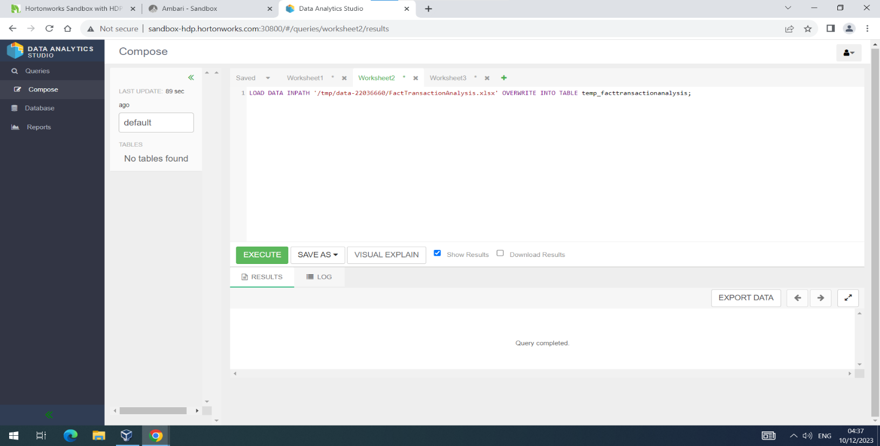Now, the table thus created is loaded with data from the flat file which was stored earlier. The path should be exactly the same or else the query gives errors. This was achieved using the following commands:

**Fig.34 Loading data into temporary table**

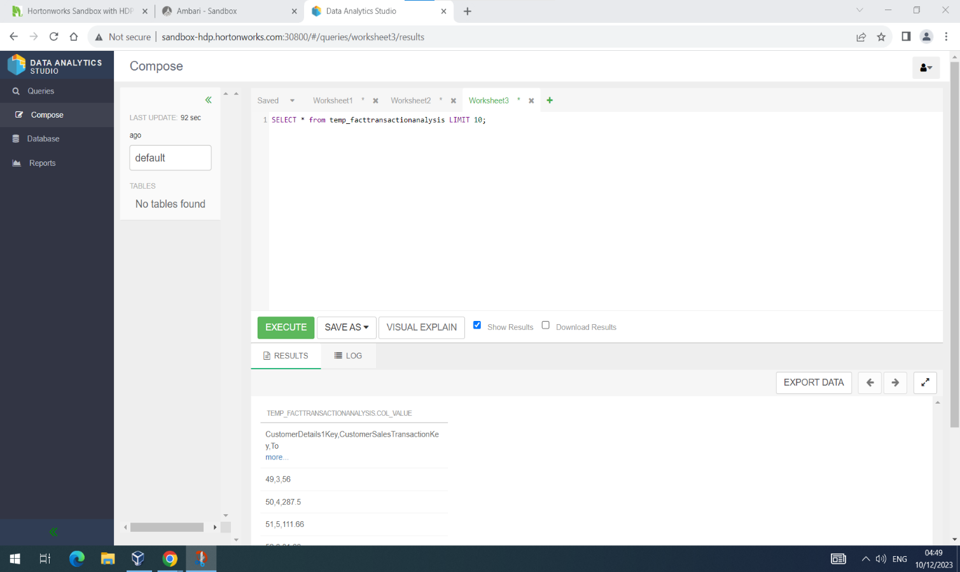After loading the data, the table data is visualized as follows:

**Fig.35 Visualising the data in temporary table**

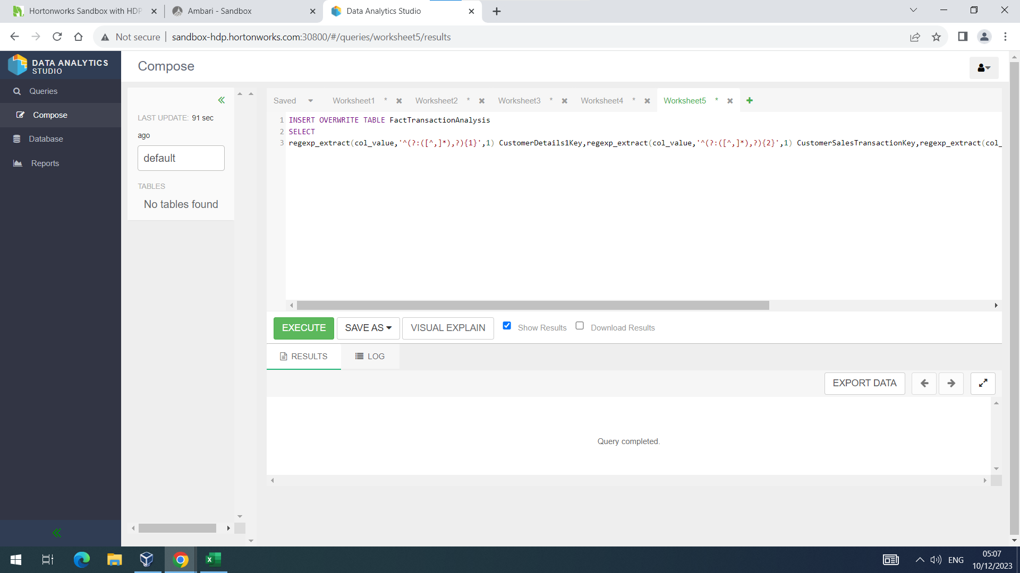This is not the format in which the data should be stored. Hence, the data is now overwritten into table FactTransactionAnalaysis which is created in a similar way in which table temp_facttransactionanalysis was created in the following manner:

**Fig.36 Overwriting the data into table FactTransactionAnalysis**

It is noteworthy that regular expressions are used to store the data in the desired format into the table FactTransactionAnalysis. The table now contains data in the following format:

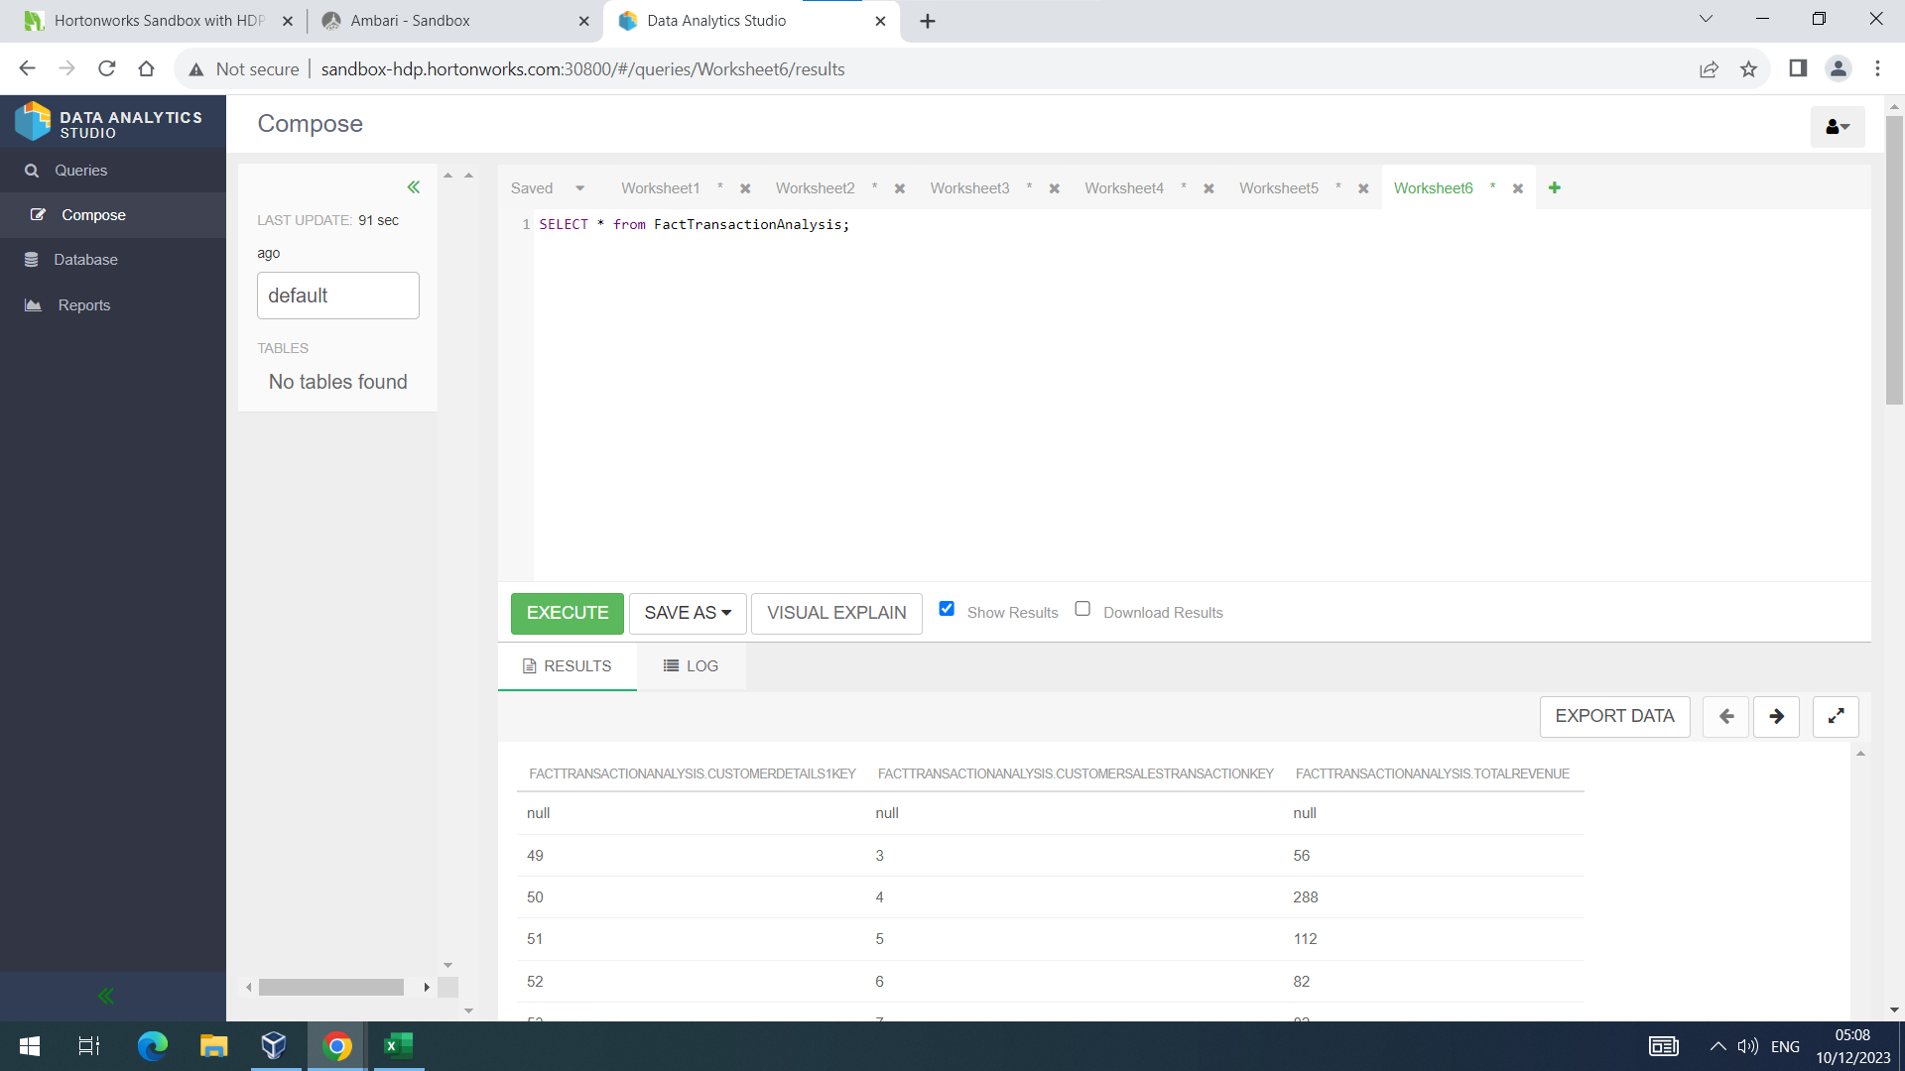

**Fig.37 Suitable Data Structure in HIVE**

* 1. **Demonstrate the use of Apache Pig for manipulating the loaded data**

The following steps are followed to demonstrate the use of Apache Pig:

* The flat file was initially downloaded on the virtual machine.
* Then the docker environment was initialized on the virtual machine which was already preinstalled on it.
* The Ambari environment was initialized by connecting to the localhost:1080.
* By clicking on Files View, a folder named user was located.
* Inside user, a new folder called maria_dev was located.
* Inside maria_dev, the flat file called FactTransactionAnalysis was uploaded using the upload button as seen below:

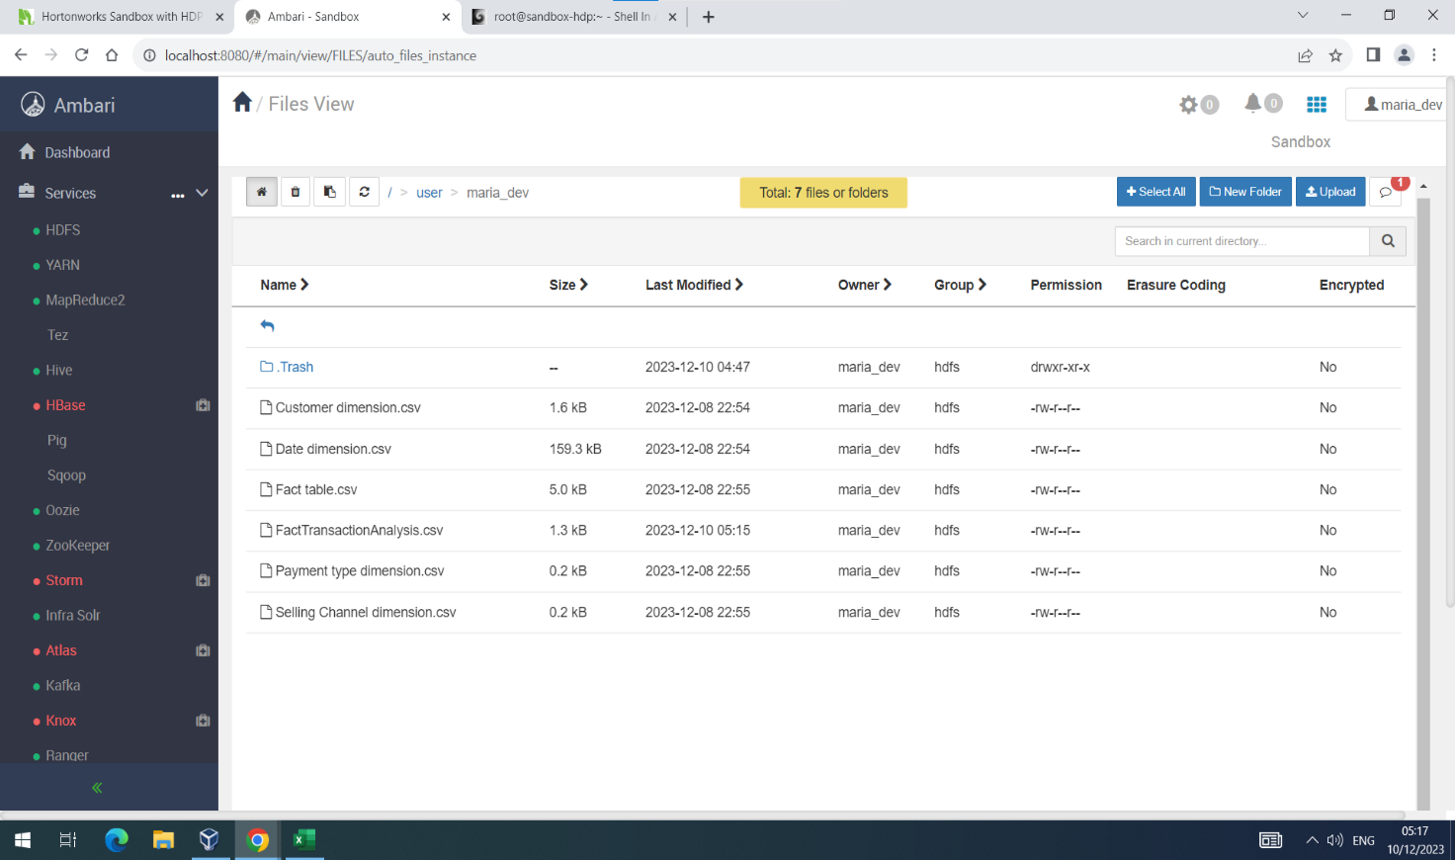

**Fig.38 Uploading the migrated flat file to Apache HDFS**

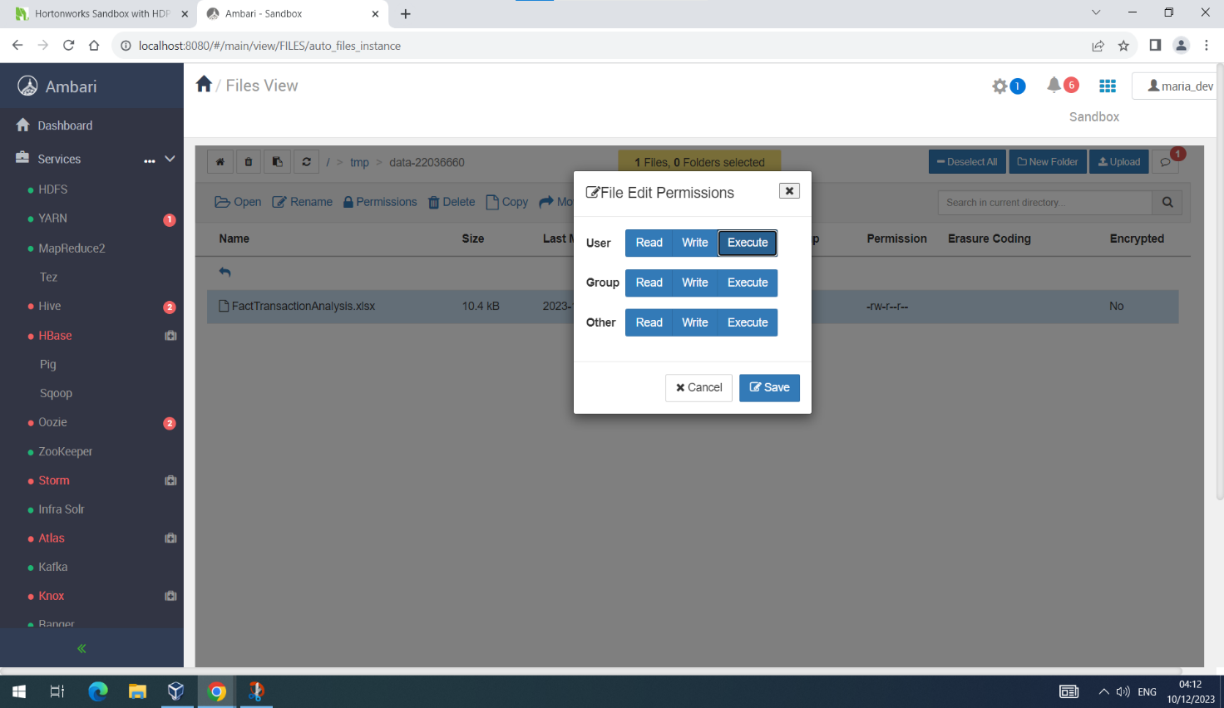After uploading the flat file, the permissions of the file need to be changed in a way that it should be writable. Hence, the write permissions need to be ticked blue to perform manipulations on the data file as seen below:

**Fig.39 Setting permissions to make the file writable**

Now, the Apache Pig environment was initialized by connecting to sandbox-hdp.hortonworks.com:4200.

The first step here was to login as root using the given details. Then select maria_dev as the super directory and create a new file called trans_analysis in vi editor using the vi command as seen below:



**Fig.40 creating a new file in Pig**

The next step is to load the flat file data into this file using LOAD command by specifying the path of the flat file. After that, the flat file columns are mapped to the columns of the file created in Pig using AS command. Finally, DESCRIBE command is used to show the output of the Pig file which can be seen below:



**Fig.41 Pig commands**

Then this file needs to be saved using escape followed by :x. This will save the file in the system return the cursor to command prompt. Then, the command pig -f trans_analysis is used to run the saved file which gives the following output:

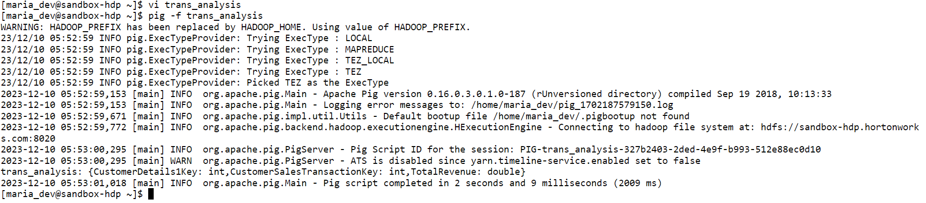**Fig.42 Output of Pig Command**

The subset command can be used to create a subset of the data structure using commands in Pig. The DUMP command is used to see the contents of the data structure in detail. These commands can be used as follows:

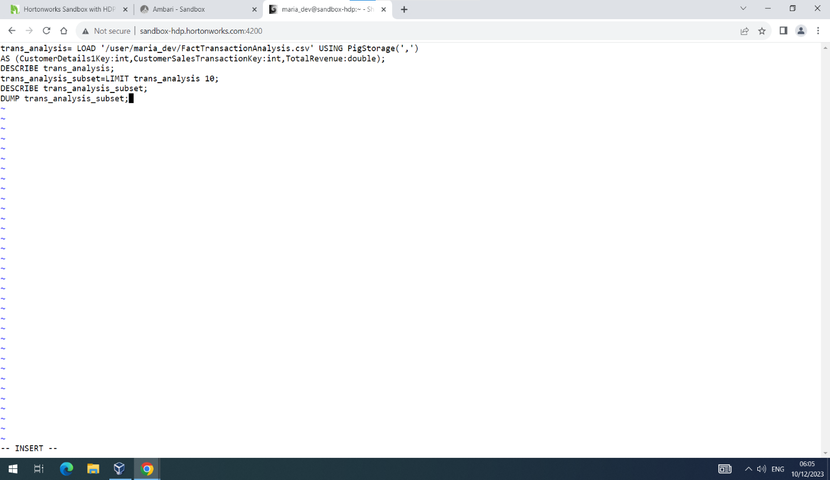

**Fig.43 Appended Pig Commands**

These commands can be appended to the previous file easily. The previous file can be opened by typing vi [filename]. To insert into vi editor “i” needs to be pressed. The following output is obtained on running the above code:

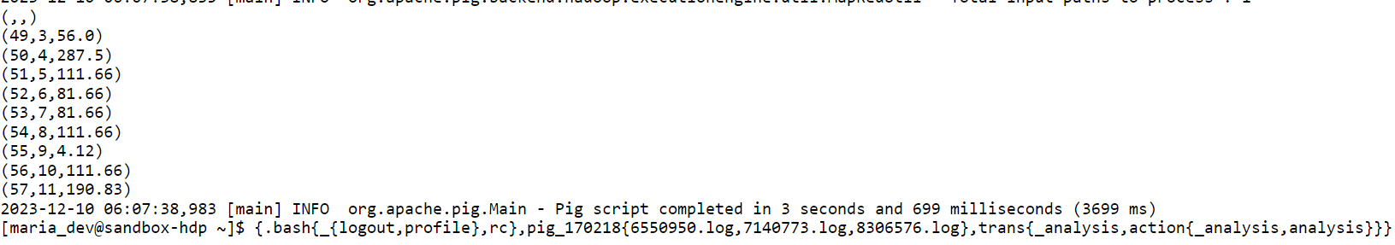

**Fig.44 Output of DUMP command**

**Conclusion:**

Initial part of the case study (Part-A) was completed in an agile environment. This presented a great opportunity to collaborate with the team members and reflect on each other’s ideas. Each individual carried out the tasks on hand to perfection and gave their all to make the case study a success. Many brainstorming sessions were carried out which involved productive discussions on the designing of the data dimensional model. Other benefit of working in the agile environment was that each individual was committed to a particular task which was narrowed down to after many interactive sessions. This helped all team members to focus on the task at hand and develop their expertise in their respective area of interest. This also greatly enhanced the productivity as the tasks at hand were completed in a rapid manner and also showed great accuracy and finesse. The data dimensional model was approved by the tutor with minor changes which were implemented at a later stage to improve the model accuracy and design.

The next part of the case study (Part-B) was completed individually and it was one roller coaster of a ride as it was pretty challenging and exciting at the same time. It involved the use of various technologies such as SQL, HIVE and Pig. The whole idea was to get a good experience of dealing with big data and exactly how it works in the industry. It was a very good experience as a lot of new technologies were introduced to and worked upon to achieve the objective of designing, implementing and testing a data warehouse based on the given data. The process was challenging as it was difficult to learn and use new technologies in such a short space of time but was equally rewarding as it enhanced the ability to work on big data processing. Managing and implementing big data methodologies was very essential as it aided the business personnel in making critical decisions based upon the findings of various data processing methods. It can be of great help if someone aspires to be a successful entrepreneur as it assists business growth in many ways. Of all the technologies learnt and used, SQL was found out to be the best and most lucid as it is easy to understand and implement and can meet almost all the requirement analysis. HIVE and Pig were pretty straight forward as well but were much more complex than SQL as they were used in an altogether different environment which were used for the first time. The most important and useful process was the ETL process as it is widely used in the data industry and particularly by fintech companies who deal with tons of large real time data. All in all it was an enthralling experience and a very engaging one as well as it took a lot of effort and time to achieve the objectives of this case study but was equally enjoyable, informative and practical in the way it was approached.